Hilltop Server

November 2018
Contents
Introduction 1
Installation 1
Firewalls 1
Configuration File 2
IIS Configuration 3
Command Structure 6
Server Control 6
Hilltop Service 8
Site List 8
Measurement List 10
Collection List 12
Site Meta-Data for a Given Site 12
Thresholds 12
Data 13
Data Tables 18
Recent Data in a Table 19
All Data in a Table 20
Comments 20
Ensemble Statistics 21
Images 21
Pre-defined Graphs 21
Data Entry from a Tablet 23
Data Upload 23
Roll your own Data Upload 24
CSV Import 25
OGC Services 26
Web Feature Service 26
Sensor Observation Service 27
Service Provider Information 27
Controlled Vocabulary 28
Clients 32
Graph 35
A More Modern Look 36
Time Axis Label Orientation 36
Sparklines 37
Axes 37
Traces 38
Bar Graphs 39
Labels 39
Thresholds 41

Introduction
Hilltop Server is an IIS Native Module that can serve data and images to a client application. The client sends a request to the server and the server will reply with the required information. Currently the server provides data and graphs, and can accept field data from tablets. It will be extended to perform the statistics performed in Hilltop Hydro. Most of the responses from Hilltop Server are prepared in XML. JSON is important for web pages, and Hilltop Server can generate JSON on demand for certain requests.

Installation
The server requires IIS Version 7.5 or better and must be deployed in a 64-bit environment. This means the operating system must be Windows Server 2008 R2 or Windows 7 (64-bit). The Hilltop Server does not use ASP .Net so you don’t have to install it. You can use the default application pool in IIS, or choose to run the Hilltop Server in its own pool. Choosing a separate pool for the server can be useful if you want to give the Hilltop Server credentials. You should also ensure the Hilltop Server has access to data files and to the meta data in SQL Server. The data files should be visible on the network. Remember that IIS applications belong to an Active Directory group called IIS_IUSRS. This group doesn’t have enormous privileges but can get to data files on the C: You will need to give the application pool its own username and password if the data files are on a networked computer.

Firewalls
The server is likely to be deployed on the outside of a firewall and facing the Internet in a demilitarised zone. That said it needs to have its own data files and meta-data. The server needs to connect to both the Hilltop Tables in a SQL Server database, and Hilltop data files, such as *.hts, and *.dsn . There are three ways to do this and the solution you choose will depend on the firewall on the network.

Direct Connection
In this method, Hilltop Server is installed on the business LAN and has immediate access to the Hilltop Tables and the data files. The server is just another program on the network. The firewall is configured to inspect http requests from the Internet and then route the relevant ones through the firewall and on to the computer running Hilltop Server.

Relay
This configuration has a computer in a demilitarised zone that runs Hilltop Server. It has an instance of SQL Server Express for the meta-data, but does not have the Hilltop data files on it. Requests for data are relayed to a second server in the business LAN. This method means you have a pinhole connection between the DMZ computer and the computer in the business LAN, but it can be on a non-standard port. The firewall will check connection attempts on this non-standard port, and will only allow connections from the DMZ computer to the second Hilltop Server. A computer on the outside will not be able to connect to the internal Hilltop Server.

Full DMZ
This last configuration is the least favourable. Hilltop Server runs in a demilitarised zone and has both a SQL Server Express instance for the meta-data and the Hilltop data files on it. You use SQL Replication to send updates from the Hilltop database on the business LAN, and Hilltop Replication to send updates from the Hilltop data files. You need to install a copy of TxSend on a machine in the business LAN, and the Telemetry Computer is the usual choice. TxSend sends the replication documents to the Hilltop Server using HTTP.
You should also enable a direct file connection from a selected computer in the business lan to the machine in the DMZ. This is important so that complete Hilltop files can be sent using XCopy, rather than just the piecemeal approach of sending replication documents with TxSend. Replication works fine most of the time, but you need to be able to send complete files in an emergency.

Configuration File
The connection to SQL Server is done through HilltopSystem.dsn, as per all other Hilltop programs. You will find it easiest to have the Hilltop Server log in with a SQL Server user name and password. An example connection file is shown below.
[ODBC]
DRIVER=SQL Server Native Client 10.0
Trusted_Connection=No
SERVER=(local)
UID=HilltopServer
DATABASE=Hilltop

[Hilltop]
HasComments=1
AccessCode=CER
PWD=d9c58feeb2c893b1353c8ced5bc427599058fb8a8e7b012dc9dd5f84a9044f81

[Server]
DataFile=C:\IData\Data\ServerDemo.hts
ProjectFile=C:\IData\Data\Demo.hpr

Notice the TrustedConnection setting is off so SQL Server expects a user name and password. There is a UID entry in the ODBC section and this provides the user name. The password is not allowed in the ODBC section so is placed in the Hilltop section of the file. Enter the password in plain text in the PWD entry and then start Hilltop Manager. Manager will read the password and then encrypt it.
The Server section in the HilltopSystem.dsn configures the server. You must name a data file, and can optionally name a project file. Collections in the project are available for use in many of the commands and help you design a dynamic web site.

Operation in a DMZ
Operating in a demilitarised zone creates a number of problems. An annoying one is where virtual measurements attempt to read data from another data file, but that file is not available on the server. The virtual measurement can’t run but it takes several seconds for Windows to signal that the file is unreachable. Requests like the measurement list or the WFS GetFeature may cause the client software to time out.
The solution is to tell the server that it can only get to files that are on local disk drives. Mapped drives and filenames with a UNC are rejected and the associated virtual measurement is not reported. Add a LocalDataFilesOnly entry into the Server section of the HilltopSystem.dsn file. For example:
[Server]
DataFile=C:\IData\Data\ServerDemo.hts
ProjectFile=C:\IData\Data\Demo.hpr
LocalDataFilesOnly = 1

Common Names
Common Names are used in Hilltop to assign a nice name to a file name. The assignment is done in Hilltop Manager using the Edit – File Names menu item and the names are stored in the Hilltop database. The result is that virtual measurements and script can refer to the file using its common name and then Hilltop will use the proper filename. Hilltop identifies a common name by a tilde as the first character. For example, a Get statement in a virtual measurement may look like:
Get Flow from ~Telemety

The Telemetry common name will resolve to a proper file name, and this is usually a UNC, for example:
~Telemetry \\TelemServer\Data\Telemetry.hts

There is a big problem here if Hilltop Server is in a DMZ and cannot see the domain controller, and so cannot resolve the UNC. The server may well be able to read the file, but may do so through a different UNC, for example:
~Telemetry \\192.168.1.25\Data\Telemetry.hts

Hilltop programs can read the list of common names from the HilltopSystem.dsn file and will ignore the database entries. This lets the server have its own set of common names and you can test their operation by running Hilltop Manager on the server. For example:
[Common Names]
Telemetry = \\192.168.1.25\Data\Telemetry.hts
Archive Data = D:\Hilltop\Data\Archive.hts

Blanks around the equal sign are optional and the common name can have blanks in it too.
You can also use the configuration file to indicate common names that are unreachable. Put the common name in the Common Names section, but don’t assign it to anything. Hilltop will see that it can’t get a file name and will produce an error message quickly. For example:
[Common Names]
Telemetry = \\192.168.1.25\Data\Telemetry.hts
Not Here =
Archive Data = D:\Hilltop\Data\Archive.hts

IIS Configuration
The next steps involve telling IIS about the Hilltop Server and mapping it to a URL . This is done through the IIS Manager and there is a shortcut to this application in the Administrative Tools section of the Windows Control Panel.

Registering the Module
Click on the server name in the Connections window, and then double click the Modules item. Note there is a Modules item visible when you have a selected an entry from the Site tree item, but this is not the right one. You need to click on the top most item in the Connections tree control.
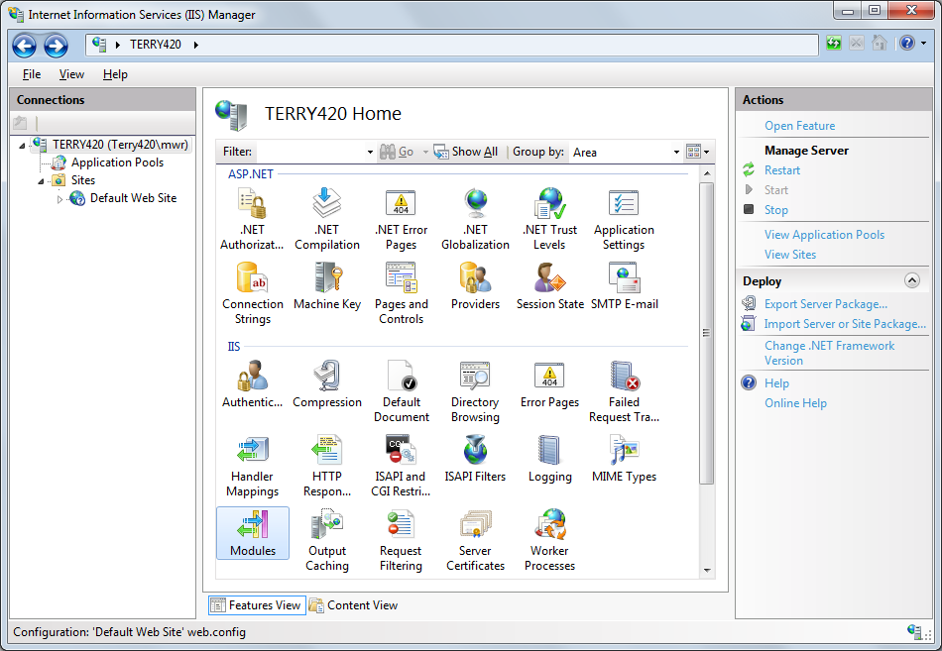
The Modules screen will start once you double click on the Modules item. There will be a “Configure Native Modules” link in the Actions panel on the right hand side. Click the link and a dialog will start. Click the Register button to start a second dialog
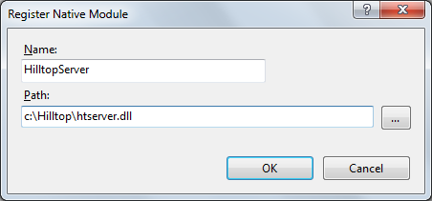
Give a name to the server and then say where you have placed the DLL. The Hilltop Server DLL can live in any directory that IIS can get to, and the HilltopSystem.dsn file must be in the same directory. Click and OK button and you will then see the Hilltop Server in the list of modules.

Mapping the Module
The Hilltop Server gets mapped to a given filename extension, and this would typically be “*.hts” . This means that any URL that has .hts at the end of the path will be processed by Hilltop Server. Click on the Web Site that you want to accept the requests, and then double click on the Handler Mappings item.
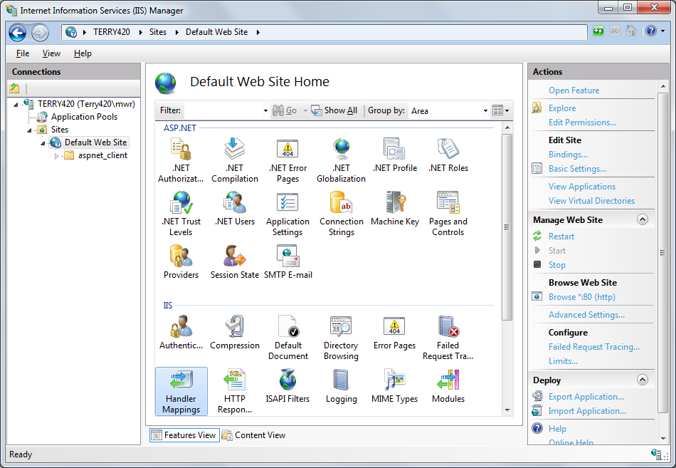
The Handler Mappings screen will start and there is an “Add Module Mapping” link in the Actions pane. Click this and a dialog will start.
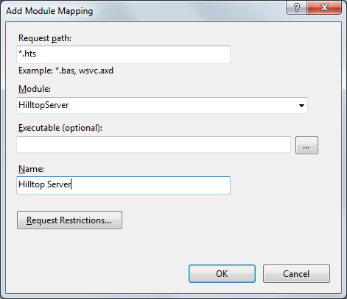
Enter “*.hts” in the Request path field and select the Hilltop Server from the Module combo-box. It should be there!! . Finally give a name to the Handler Mapping and click OK.
IIS Version 8.x may default to a request restriction that is too restrictive. Click the Request Restrictions button and then un-tick the “Invoke handler only if request …” button. We want the Hilltop Server to get any request for anything. You will need to follow this step if you get “Error File Not Found” or “80007002” error numbers when you try testing the server from a browser.

Compression
It is extremely sensible to enable dynamic compression in IIS and this means that IIS will compress the XML before it sends it to the client. Compression is done at the request of the client, so you don’t have to ask for compression if you are writing your own client. Hilltop Manager et al will ask for compression because they can cope. Don’t disappoint them.
Click on the web site item in the Connections pane, and then double click on the Compression item.
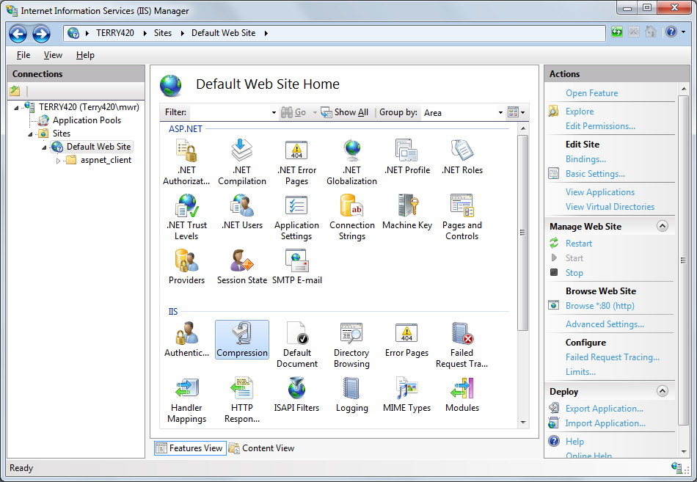
Enable dynamic compression, and ignore the gloomy message in the Alerts pane.
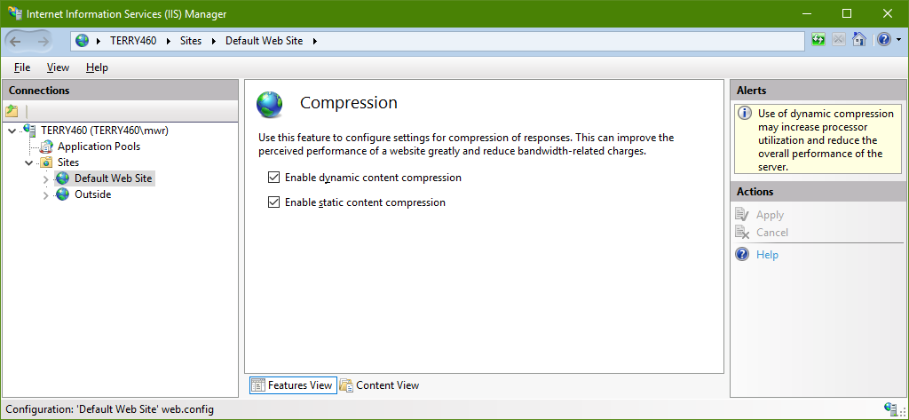
The server is now ready. Start Internet Explorer on the computer that is running IIS and enter a URL to get to the server. For example, if you are using the default web site, the URL would be http://localhost/hopeful.hts . Note that you can use anything as a filename before the filename extension. The server will reply, and you will see an HTML document proclaiming the server’s existence. The server will send an XML document if it has trouble connecting to the meta-data or the data file.
The final stage is to try to connect to the server from another computer, either inside the network, or from the outside. As before, craft a URL that has “.hts” has the filename extension.

Command Structure
Hilltop Server accepts a URL with Key-Value Pairs on it. This structure was introduced with CGI when the Internet was little, and the construct has now been re-badged as REST. The Hilltop Server does not claim to be a RESTful Server though, it’s more ADHD.
An example URL is as follows and is sent to the server using an HTTP GET statement.
http://host/data.hts?Service=Hilltop&Request=SiteList

There is a question mark after the filename extension, and each key-value pair is separated by an ampersand. In accordance with the rather strange OGC specification, the key can be in any case, but the value is case sensitive. All URL’s sent to the server must have Service key and a Request key.
A client connecting to the server can retrieve data and images from the server, but it can also ask the server what data is available. Clients such as Hilltop Manager will interrogate the server in order to build the tree control, and clients like htsUpdate will already know what sites and measurements they want, so just ask for the data.

Server Control
The server is configured through entries in the HilltopSystem.dsn file and you set these as required. New settings are only read when the server starts, or after you issue a Reset command.

Server Reset
The server can detect changes in the data file and it will make sure it keeps up with new data. However, it caches its connection to the meta-data and to the Project file. This means you need to reset the server if you add new meta-data such as measurement or data source, or if you change a collection in the Project file. You must also reset the server if you make any changes to the HilltopSystem.dsn file. You can reset the server through a URL and the simplest thing is to have a favourites item in your browser. An example URL is:
http://host/data.hts?Service=Hilltop&Request=Reset

Version Number
Hilltop Software is forever making changes to the software and it is helpful to know what version of the server you are talking to. The server will send this to a browser using the Version request. An example is:
http://host/data.hts?Service=Hilltop&Request=Version

Other Data Files
The default data file is set in the Server section of the HilltopSystem.dsn file. You can read from other data files by creating extra entries in the HilltopSystem.dsn file and then using the entry in the filename part of the URL. For example, the default data file may be the main archive, or the archive plus the telemetry file. However, you may want to see the telemetry file by itself. Create entries in OtherServerDataFiles section of the HilltopSystem.dsn file:
[Server]
DataFile=C:\IData\Data\ArchivePlusTelemetry.hts
ProjectFile=C:\IData\Data\Demo.hpr
FormFile = C:\IData\Data\Forms.hts

[OtherServerDataFiles]
Telemetry = C:\IData\Data\Telemetry.hts
Archive = C:\IData\Data\Archive.hts

Use meaningful names for the entries in the OtherServerDataFiles section, and do not have blanks in the entry names.
You read data from the other files by giving the entry name in the filename part of the URL. For example:
http://host/Telemetry.hts?Service=Hilltop&Request=SiteList
http://host/Archive.hts?Service=Hilltop&Request=SiteList

The comparison between the filename part of the URL and the entries in the configuration file is not case sensitive.

Collections
The server can make good use of collections, particularly matrix collections. You can use collections to offer a selection of sites and measurements, or provide data for all sites and measurements in a collection. It is worth remembering that as of August 2013, a matrix collection can get its site names from an ESRI Shape File. This means that you can offer sites based on polygon searches done inside your GIS software.
The collections are expected to all be in one project file. You name the project file in the Server section of HilltopSystem.dsn. For example:
[Server]
DataFile=C:\IData\Data\ServerDemo.hts
ProjectFile=C:\IData\Data\Demo.hpr
FormFile = C:\IData\Data\Forms.hts

Map Projections
The server reads the easting and northing fields from the Hilltop Sites table and will convert to latitude and longitude if asked. It needs to know which projection you are using and will take a wild guess based on the easting. An easting less than 2 million is taken to be in NZTM2000. This works fine for most sites in New Zealand, but does not work for any sites east of Wairoa.
You should state which projection you are using in the HilltopSystem.dsn file, and this removes the guesswork. For example:
[Hilltop]
Projection = NZMG ; The 1949 standard for easting and northing
Projection = NZTM2000 ; The new fangled modern standard

Note that you put the MapProjection entry in the Hilltop section, not the Server section. This is because this setting is used by other Hilltop programs, notably the Catalogue object in Hydrolib.

Data Request Limits
The features of Hilltop Server mean that users shouldn’t be copying all the data off the server and they should be getting the server to do the statistics instead. It is also not a great idea to have people holding copies of your data, especially when rated data can change. The server can limit the duration of data that clients can read from the server. The data limit is expressed as an interval, and limits data to the given interval back from the current date. Insert an entry in the Server section of HilltopSystem.dsn. For example, to limit data requests to 2 years back from today:
[Server]
DataLimit = 2 years

The data limit only applies to the GetData, DataTable and GetObservation requests. Requests for graphs and statistics can be made over the entire time range.

Data Request Logs
You may wish to know who is fetching data from your server. GetData and GetObservation requests can be logged and the details of the request are written to a file. You specify the directory for the log file, and Hilltop Server names the file with today’s date. Identify the directory in the Server section of HilltopSystem.dsn, and make sure that the server has write access to the directory. For example:
[Server]
DataRequestLogDir = C:\Hilltop\Logs\Server\

The log file has the IP address of the client that asked for the data. You can get the domain name of the computer by going to www.whois.com/whois and typing in the IP address.

Hilltop Service
The server offers a set of native requests through the Service=Hilltop key. The use of proprietary protocols is often frowned upon, but it enables rapid delivery of features that aren’t part of accepted standards. For example, the Hilltop service can prepare a graph for display on the client. Such activity is not standardised.

Site List
The SiteList request will deliver an XML or JSON document that shows the sites on offer. A typical XML response is:
<?xml version="1.0"?>
<HilltopServer>
<Agency>Hilltop Headquarters</Agency>
<Site Name="Alphabet River at Crossword"> </Site>
<Site Name="Anakina River at Duntroon"> </Site>
</HilltopServer>

Note the Agency element because you may need to put entries in the Hilltop Transfers table to convert the site names and measurements to your local settings.
You can ask the server to provide the location of the sites. Use the Location key and set this to either “Yes” or “LatLong”. The Yes setting gives the easting and northing and the LatLong setting gives latitude and longitude in NZGD2000 format. For example:
http://host/data.hts?Service=Hilltop&Request=SiteList&Location=Yes

will return:
<?xml version="1.0"?>
<HilltopServer>
<Agency>Hilltop Headquarters</Agency>
<Site Name="Alphabet River at Crossword">
<Easting>2561014</Easting>
<Northing>5982791</Northing>
</Site>
<Site Name="Anakina River at Duntroon">
<Easting>2129920</Easting>
<Northing>5485470</Northing>
</Site>
</HilltopServer>

A URL to give latitude and longitude looks like:
http://host/data.hts?Service=Hilltop&Request=SiteList&Location=LatLong

and will return something like:
<?xml version="1.0"?>
<HilltopServer>
<Agency>Hilltop Headquarters</Agency>
<Site Name="Alphabet River at Crossword">
<Latitude>-41.36010270</Latitude>
<Longitude>173.60985234</Longitude>
</Site>
<Site Name="Anakina River at Duntroon">
<Latitude>-45.73724556</Latitude>
<Longitude>168.11528305</Longitude>
</Site>
</HilltopServer>

Filters
Other keys let you get site information to help build a map layer. The output is the same, but is filtered by the keys. You can provide a bounding box to the server and so only see sites inside the box. You can also give a measurement name, and the server will only show sites that have the given measurement. Example URL’s are:
http://host/data.hts?Service=Hilltop&Request=SiteList&Location=Yes&
BBox= 2100000,5400000,2180000,5600000

http://host/data.hts?Service=Hilltop&Request=SiteList&Location=Yes&
Measurement=Flow

http://host/data.hts?Service=Hilltop&Request=SiteList&Location=Yes&
BBox= 2100000,5400000,2180000,5600000&Measurement=Flow [Water Level]

Bounding Box Filter
The BBox key accepts two easting and northing pairs by default. These define two points diagonally opposite to each other. The order of the pairs is not important, but the easting precedes the northing in each pair. The BBox key can be in lat/long if you wish and you use a shortened version of the OGC format. For example to send a bounding box in WGS84:
BBox=-46.48797124,167.65999182,-44.73293297,168.83236546,EPSG:4326

Valid EPSG numbers are:
EPSG:4326 WGS84 lat and long
EPSG:2193 NZTM 2000
EPSG:27200 NZMG
EPSG:4167 NZGD 2000

Life is simpler if you use eastings and northings in the same projection as the server is sending them. The server can convert from NZMG to NZTM2000, but not the other way.

Measurement Filter
You can also give a measurement name, and the server will only show sites that have the given measurement. The measurement can include a data source name if required. Note that you must use the names that the server will understand, not the names of measurements on your own system. This isn’t a problem with bog-standard surface water measurements like flow and rainfall, but it is important for Water Quality data. The simplest way to find out the measurement names in use at the server is to ask it for a measurement list.

Site List via a Collection
The site list request can accept a collection name, and will list the site names in the given collection. This feature is handy for a web site that wants to load a tree control or combo-box with a list of suitable sites. The web site can be crafted to always load a known collection name, but what appears is controllable through the collection. This means you don’t have to change the web site to offer extra sites. An example is:
http://host/data.hts?Service=Hilltop&Request=SiteList&Collection=WQSites

The Location and BBox qualifiers are still available if you want to generate a map layer. The Measurement qualifier is not available.
The server can build a list of sites based on all the collections in the project. This is useful when you have a set of collections based geography or measurements, but want to load a combo-box on a web site with all available sites. Give a collection name of "~All" and the collection name is case sensitive. The server will read all the collections in the project and build a new collection on the fly. It will remove duplicates. An example is:
http://host/data.hts?Service=Hilltop&Request=SiteList&Collection=~All

Site Meta-Data
The Sites table in the Hilltop database has columns in it that may be useful in a site list. The location, catchment area and altitude are stored in their own columns and all other parameters are stored in an XML document. The XML document contains the parameters that Lawa uses for the Monitoring Site Reference Data map layer plus any key-value pairs you created in the Extras tab of the Sites Editor. You can ask for selected site parameters with the SiteParameters keyword and give a list of the parameter names separated by a commas. For example:
http://host/data.hts?Service=Hilltop&Request=SiteList&
SiteParameters=CatchmentArea,Altitude,AirTown

You can also have "Location" as a parameter and the server will show the easting and northing. This is the equivalent of the "Location=Yes" key-value pair. Consult the Lawa documentation for the names of the columns used in the Monitoring Site Reference Data map layer, or look at the SiteInfo column in the Sites table with SQL Server Management Studio.
Meta-data is available when you ask for a site list via a collection. Specify the collection name and the SiteParameters as required. For example:
http://host/data.hts?Service=Hilltop&Request=SiteList&Collection=WQSites&
SiteParameters=CatchmentName

Site List for a Web Page
A web page may wish to load a drop down list with a list of site names. Javascript can issue a SiteList request and process the XML response, but it is rather painful. The SiteList accepts a Target qualifier that tells it to prepare JSON suitable for populating an HTML Select element. An example is:
http://host/data.hts?Service=Hilltop&Request=SiteList&Target=HtmlSelect

The response from the server is an array of site names that can be easily loaded into a select element on the web page. A typical JSON response is:
{ "Options" : ["Alphabet River at Crossword", "Anakina River at Duntroon"]}

The SiteList request won’t supply any meta-data or location information because the select element won’t know what to do with it. However, the bounding box filter still works, as does a site list based on a collection or a measurement.
Site Synonyms
You may wish to load site name synonyms into the drop down list. In this case, the Html Select element needs both the text to display and the Hilltop site name to send back to the server when the page wants data. The SynLevel qualifier specifies the synonym level, one or two, and the JSON response is an array of objects. Each object has an the text to display and the actual site name for use with a data request.
A typical request is:
http://host/data.hts?Service=Hilltop&Request=SiteList&Target=HtmlSelect&SynLevel=1

and a response is:
{ "Options" : [
{"Option": "Alpha Falpha", "Value": "Alphabet River at Crossword"},
{"Option": "Duntroon", "Value": "Anakina River at Duntroon"}
]}

The Option pair has the text for displaying the drop down list, and the Value pair has the actual site name.

Measurement List
The Hilltop Server can tell you what measurements are available at a site, and will give the time range of available data. The measurement list includes all the time series types that Hilltop has, so the list will include Check Data and Quality Data. The Request key is set to MeasurementList and there must be a Site key set to the site name you require the information on. For example:
http://host/data.hts?Service=Hilltop&Request=MeasurementList&Site=Alphabet
River at Crossword

The output is not shown here because it does go on a bit. Sufficient to say that the elements in the XML are hopefully obvious and contain all the important meta-data that is stored in the server’s database.

Measurement List via a Collection
This variation offers a short list of the site/measurement combinations in the given collection and gives the time range of the available data. The command accepts matrix collections and will only show a site/measurement combination if there is data in the file. Name the collection instead of a site name, for example:
http://host/data.hts?Service=Hilltop&Request=MeasurementList&Collection=WQSites

You can use the Site and Collection keywords together and the server will only show the measurements at the given site. This request is useful if the collection is a matrix collection with only measurements, or has measurements and site names. Note that the given site name must be in the collection if the collection has site names. In other words, this command is best used with a collection that just has measurements in it.
The server can build a list of measurements based on all the collections in the project. This is useful when you have a set of collections based geography or measurements, but want to load a combo-box on a web site will all available sites. Give a collection name of "~All" and the collection name is case sensitive. The server will read all the collections in the project and build a new collection on the fly. It will remove duplicates. An example is:
http://host/data.hts?Service=Hilltop&Request=MeasurementList&Collection=~All

You can still use the Site keyword with the ~All collection. This will just show the measurements at the given site.

Measurement List for all Sites
The request will work without giving a site name and in this case it will give a list of all the measurements in the data file. The list is not sorted and a measurement is listed in the order it is found in the data file. This command is good for loading a combo-box on a web page that shows the available measurements. A user can then select a measurement and see a map layer of sites that have data for the measurement. An example is:
http://host/data.hts?Service=Hilltop&Request=MeasurementList

A typical reply is as follows. The data source name will be enclosed in brackets if it is needed.
<?xml version="1.0"?>
<HilltopServer>
<Agency>Hilltop Headquarters</Agency>
<Measurement Name="Stage" />
<Measurement Name="Flow" />
</HilltopServer>

You can ask for the units of each measurement. An example request is:
http://host/data.hts?Service=Hilltop&Request=MeasurementList&Units=Yes

A typical reply is:
<?xml version="1.0"?>
<HilltopServer>
<Agency>Hilltop Headquarters</Agency>
<Measurement Name="Stage"><Units>mm</Units></Measurement>
<Measurement Name="Flow"><Units>m3/sec</Units></Measurement>
</HilltopServer>

Measurement List for a Web Page
A web page may wish to load a drop down list with a list of measurements. The MeasurementList accepts a Target qualifier that tells it to prepare JSON suitable for populating an HTML Select element. The request works with a list based on a collection, or it can deliver all measurements for all sites. An example is:
http://host/data.hts?Service=Hilltop&Request=MeasurementList&Target=HtmlSelect

http://host/data.hts?Service=Hilltop&Request=MeasurementList&Target=HtmlSelect&
Site=Alphabet River at Crossword

The response from the server is an array of measurements that can be loaded into a select element on the web page. A typical JSON response is:
{ "Options" : ["Stage", "Flow", "Stage [Gauging Results]”]}

Fetching the Time Range
The time range of the available data is useful information and a web page may wish to display this once someone has selected a measurement. The TimeRange request accepts a site name and measurement and will return an XML or JSON object with the time range in it. An example is:
http://host/data.hts?Service=Hilltop&Request=TimeRange&Site=Alphabet
River at Crossword&Measurement=Flow&Format=JSON

A typical JSON response is:
{"Site":"Alphabet River at Crossword","Measurement":"Stage",
"From":"1956-10-26T11:00:00+12:00","To":"1996-07-25T08:45:00+12:00","Units":"mm"}

Collection List
The client can ask for a list of the collections and the items in it. For example:
http://host/data.hts?Service=Hilltop&Request=CollectionList

The server will reply with the entire project file in an XML document. Hilltop projects are usually in the “.hpr” format, but Hilltop Manager and Hydro will accept projects in XML. The XML sent by the server is the same as used by Hilltop programs.
An example of a project with a single matrix collection in it is:
<?xml version="1.0"?>
<HilltopProject>
<Collection Name="Flows">
<Item><Measurement>Flow</Measurement></Item>
<Item><SiteName>Anakina River at Duntroon</SiteName></Item>
<Item><SiteName>Alphabet River at Crossword</SiteName></Item>
<Item>
<SiteName>Casey Farm</SiteName>
<Measurement>Flow [Water Level for Small Streams]</Measurement>
</Item>
</Collection>
</HilltopProject>

Site Meta-Data for a Given Site
The Sites Table has information about the names and location of the site, but also has a lot of other meta-data. Some fields in the table are in their own columns, such as the catchment area, while others are in an XML object. You are free to populate this object with name value pairs of your own design and then retrieve them as if they were fields in the database table. The server can list all the meta-data stored for a site, or selected items. For example:
http://host/data.hts?Service=Hilltop&Request=SiteInfo&Site=Alphabet
River at Crossword
http://host/data.hts?Service=Hilltop&Request=SiteInfo&Site=Alphabet
River at Crossword&FieldList=FirstSynonym,MedianFlow

Use the FieldList qualifier to say what meta-data you want to see, and separate the field names by a comma. Keywords to retrieve fields that have their own column in the database table will have names similar to their label in the Sites Editor, but with the blanks removed. A good trick is to use a Web Browser to ask for all the fields at a site and see what field names the server uses. Then you can craft a URL that only fetches what you actually want.

Thresholds
The Thresholds table holds information about a site/measurement combination and the server can retrieve this for you. For example:
http://host/data.hts?Service=Hilltop&Request=ThresholdInfo&Site=Alphabet
River at Crossword&Measurement=Flow

The server will prepare an XML document that has the threshold lines in it, plus the values of the other fields in the database table. The Thresholds table is the only table in Hilltop that is keyed by both site and measurement, and so is becoming a target for "Lawa Creep". Future versions of Hilltop will allow an XML document to store this stuff, and the server will dutifully supply it.

Data
The server can provide data with the GetData request and you must provide Site and Measurement keys to indicate which time series you require An examples is:
http://host/data.hts?Service=Hilltop&Request=GetData&Site=Alphabet
River at Crossword&Measurement=Stage&From=1/1/2012&To=1/11/2012

The time range is given in the From and To keys, and the values can be in any format that Hilltop understands. The server will reply in ISO8601, but you don’t have to speak to it in this format.
A fragment of a reply is:
<?xml version="1.0"?>
<Hilltop>
<Agency>Hilltop Headquarters</Agency>
<Measurement SiteName="Alphabet River at Crossword">
<DataSource Name="Water Level" NumItems="1">
<TSType>StdSeries</TSType>
<DataType>SimpleTimeSeries</DataType
<Interpolation>Instant</Interpolation>
<ItemInfo ItemNumber="1"> <ItemName>Stage</ItemName>
<ItemFormat>I</ItemFormat> <Divisor>1</Divisor>
<Units>mm</Units>
<Format>####</Format>
</ItemInfo>
</DataSource>
<Data NumItems="1" DateFormat="Calendar">
<E><T>1960-01-01T01:00:00</T><I1>23826</I1></E>
<E><T>1960-01-01T09:00:00</T><I1>23516</I1></E>
<E><T>1960-01-01T18:00:00</T><I1>23208</I1></E>
</Data>
</Hilltop>

The DataSource node contains the meta-data and is a repeat of what was sent in the MeasurementList request. The Data node contains elements for each time stamp. The <E> node surrounds each time series element, the <T> element has the time, and the <I1> element has the value of each item.

Time Range
The From and To keys set the time range for the data retrieval. You can provide both keys or use the defaults by not providing a key. The From key defaults to the start of the data and the To key defaults to the end of the data. The values for From and To are any date and time formats the Hilltop normally accepts.
The server also accepts a time range given in the ISO8601 Time Interval format. This is a start time and finish time, separated by a “/” character. A simple example is:
TimeInterval=2010-01-01T12:00:00/2011-07-01T14:00:00

ISO8601 also has the notion of a duration, being a length of time, and so there are four ways to construct a time interval. These are:
<start time>/<end time> | Both start and finish times are given
<start time>/<duration> | Read from the given start time for the given duration
<duration>/<finish time> | Set the start time back from the given end time
<duration> | Read the across the given duration

A duration in ISO8601 has the letter ‘P’ then one or more pairs of numbers and letters. The letters refer to the units, and are obvious choices. The letter ‘M’ is used for both months and minutes so the duration must have the letter ‘T’ in it before the time of day units are used. Examples are:
P1Y | One year
P10Y | Ten years
P3M | Three months
P3D | Three days
P1Y3M | One year and three months
PT3H | Three hours
PT10M | Ten minutes
PT30S | Thirty seconds
P3MT30M | Three months and 30 minutes, because you might need to.

Examples of a time interval that has a duration are:
TimeInterval=2010-01-01T00:00:00/P1Y
TimeInterval=P1Y/2011-01-01T00:00

The first example gives a year of data from the given start time, and the second example gives the year before the given finish time.

No Time Range
Not giving a time range is a request to give the most recent value. This was decided by OGC for the SOS standard and is a simple, efficient way of getting the most recent value. It works well for instantaneous data like stage, flow or temperature, but it is not sufficient for rainfall data because it always needs an interval. Thus a sample request to get the preceding 3 hours of rainfall before the end of the data is:
http://host/data.hts?Service=Hilltop&Request=GetData&Site=Alphabet
River at Crossword&Measurement=Rainfall&Method=Total&Interval=3 hours

Of course, this doesn’t solve the problem where you really do want all the data, but don’t know the time range. In this case use the “Data Start” and “Data End” settings for the time range. For example:
http://host/data.hts?Service=Hilltop&Request=GetData&Site=Alphabet
River at Crossword&Measurement=Rainfall&Method=Total&Interval=3 hours&
From=Data Start&To=Data End

Relative Time Range
A relative time range is where you provide a single duration in the TimeInterval keyword and expect to read data across a time range. For example, “TimeInterval=P1M” is an attempt to get a month’s data, but it's not obvious what the actual time range is because the finish time is not given. OGC have banned this construction in a SOS request but Hilltop assumes that the requested finish time is the end of the data. Thus "TimeInterval=P1M" sets a start time one back from the end of the data, and a finish time at the end of the data.
This behaviour may not suit reporting software that is trying to get near real-time data. Hilltop Server extends ISO8601 by allowing the “now” reserved word to be given as a finish time. An example to read three hours back from the time of the request is:
TimeInterval=P3H/now

The ISO standard for durations is case sensitive and you should treat the word “now” the same, even though it isn’t!!

Aligning the Start Time
Setting a time range back from the end of data or the current time is of little use for rainfall data because people are used to the totals being aligned to the start of a day, or the start of a month. The same comment applies if you are asking for statistics from the server such as the monthly average. Hilltop Server has an Alignment keyword that lets you set the start time on a boundary. Examples are:
Alignment=00:00 Align to the start of a day
Alignment=09:00 Align to 9 a.m.
Alignment=1 month Align to the start of the month

The start time is moved forward from the given time, and you need to take account of this when crafting a query with a relative time range. For example, the server receives a request:
TimeInterval=P1M/now&Alignment=1 month

The server sets the finish time to be the current time of the request. It next sets the start time to be one month back from the finish time, and then moves the start time forward to the start of the next month. The nett affect is that this time range represents the current month. You will need to set a duration of P2M if you want data from the month before the current month.

Data from a Collection
You can ask the server to give data for all the items in a collection. The collection can be a matrix collection and the server will expand it. Use the Collection key instead of the Site and Measurement keys. For example:
http://host/data.hts?Service=Hilltop&Request=GetData&Collection=Flows
&From=1/1/2012&To=1/11/2012

Statistics
The Method qualifier instructs the server to compute statistics of the data. Valid settings are:
Interpolate | Step through the data at the interval and give a value at each step
Average | Compute the average across the interval
Total | Compute the total in the interval
Moving Average | Compute the Moving Average at the interval, and shift it back half the interval.
EP | Exceedance Percentile
Extrema | Min, Mean, Max and amount of missing record

The choice of method can often require the use of other qualifiers to align the start time, define an interval for the averaging process, and to set a gap tolerance. By default, the results are aligned to the requested start time, and this means you must should set the start time if you want the values aligned to a particular time or use the Alignment keyword described earlier.
The Interval key accepts the interval for the statistic, and the format is the same as when giving an interval to Hilltop Hydro. Examples of the Method and Interval keys are:
http://host/data.hts?Service=Hilltop&Request=GetData&Site=Alphabet River at
Crossword&Measurement=Flow&Method=Average&Interval=1 day

http://host/data.hts?Service=Hilltop&Request=GetData&Site=Alphabet River at
Crossword&Measurement=Flow&Method=Moving Average&Interval=1 day

http://host/data.hts?Service=Hilltop&Request=GetData&Site=Alphabet River at
Crossword&Measurement=Rainfall&Method=Total&Interval=6 hours

The GapTolerance keyword lets you set a maximum total amount of missing record before the server will signal a gap. The gap tolerance is an interval and so you use the same syntax as for the Interval keyword. An example is:
http://host/data.hts?Service=Hilltop&Request=GetData&Site=Inner City&
Measurement=PM10&Method=Average&Interval=1 month&GapTolerance=1 week

The EP method reads all the data to compute the probability density function and then expresses the data in the requested time range as an exceedance percentile.
The Extrema method finds the minimum and maximum value across and interval, and also gives the average value across the interval, and the amount of missing record in the interval. The missing record is in seconds. The results are sent as six item data, and the order of the items is min, mean, max, the amount of missing record, and then the times of the minimum and maximum values. An Interval keyword is required with the Extrema statistic.
The timestamp associated with the average, total, and extrema statistics is at the end of the interval. This can make it hard for client software to display the results because monthly or annual averages appear to be in the next interval. For example, the average of all the data in 2015 is shown at zero hundred hours on 1-January-2016. The DateOnly=Yes qualifier will do Tideda's trick of making 00:00:00 be 24:00:00 on the previous day. The server suppresses the time of day, and just gives a date which is now in the year in which the averages applies to. The server also uses a different tag name to show you it has written the date instead of a date and time. Examples of time and date are:
<T>2016-01-01T00:00:00</T>
<D>2015-12-31</D>

The server sends a timestamp and value at the start time of the requested analysis when doing a fixed average or extrema calculation. This is done so that graphing software knows where to start drawing the graph from. Such software is only interested in the time, not the value, but the convention is that the value is the interpolated value at the start time. Client software that is just trying to load a table of the results should discard the first timestamp/value pair that it reads.

Rainfall Totals
Rainfall data is always totalled across an interval, and getting the server to provide the correct result requires particular combinations of the keywords. The simplest query is when the client software calculates the time range itself. For example, the relevant keywords to get three monthly rainfall totals are:
Method=Total&TimeInterval=2015-01-01/2015-04-01&Interval=1 month

An implied time range requires more care. The Alignment keyword helps, but you must remember that the Alignment keyword moves the start time forward. Thus to get the rainfall total in the previous three complete months, you need to set the duration to four months. For example:
Method=Total&TimeInterval=P4M/now&Alignment=1 month&Interval=1 month

This keyword combination will not return the total in the current month. This is because the interval is set to one month, and there isn’t a complete month of data in the final month. This behaviour is fine if you are trying to prepare a graph of recent rainfall and plotting the current month would be confusing to people who don’t look carefully.
Use the ShowFinal keyword to ask the server to give the total in the final, incomplete month. Thus the relevant keywords to show the three previous months, plus the rainfall this month is:
Method=Total&TimeInterval=P4M/now&Alignment=1 month&Interval=1 month&ShowFinal=Yes

All this comes back to how you would ask for the rainfall this month. The example above will work will work with the time interval set back to one, but the server will accept a short-hand request where you don’t give an interval. In this case, it takes the absence of an interval as a request to total across the time range. Thus the following keyword combinations do the same thing and will return the rainfall this month.
Method=Total&TimeInterval=P1M/now&Alignment=1 month&Interval=1 month&ShowFinal=Yes
Method=Total&TimeInterval=P1M/now&Alignment=1 month

A New Measurement Name
The statistics functions take a time series and turn it into another one. The receiving software may wish to store the derived data and wants to see it with a different measurement name. This is done with the SendAs keyword.
An example to fetch the last seven days of daily mean flow and send it as Daily Mean Flow is:
http://host/data.hts?Service=Hilltop&Request=GetData&Site=Alphabet River at
Crossword&Measurement=Flow&Method=Average&Interval=1 day&TimeInterval=P7D&
SendAs=Daily Mean Flow

The server does not check the realisation value against its database and it merely inserts the value into the XML. You can have a data source name enclosed in square brackets and this will go into the Data Source element in Hilltop XML and the procedure element in WaterML 2. Exercise care with the SendAs keyword when fetching data with a collection. The server applies the new measurement blindly and a mixture of measurements in your collection will all be sent as the same new measurement name.

Translating Client Specific Names
The client software may have its own set of names for sites and measurements and wants to use these instead of using your names. The LAWA web site in an example of this where it may ask for a measurement that is not the same name that you use. Provided you know in advance what the client is going to ask for, the client can have an Agency qualifier on their URL and then you can use this to set the correct site and/or measurement using the Hilltop Transfers Table.
Consider the following example where both the flow and measurement are not your names:
http://host/data.hts?Service=Hilltop&Request=GetData&Site=Alphabet&
Measurement=Stream Flow&Agency=LAWA

You need to create a LAWA agency and then set up transfer table entries. The Transfers system can translate groups based site/measurement pairs, site names and measurement names. You decide which group to do, but in most cases you will create a transfers entry for each site name, and another for each measurement. Thus in the example above, you would select the Measurements group in the Transfers Editor and add a new identifier called "Stream Flow". Set the Hilltop Measurement to your measurement, typically "Flow [Water Level".
The Site/Measurement pair transfer group is checked first. This lets you override the transfer rules for a particular site and measurement. For example, for the site that LAWA calls "Alphabet" you wish the Stream Flow to translate to "Flow [Water Level for Small Streams]". You need to select the Site Measurement Pairs group in the Transfer Editor and then add a new identifier that has the site name enclosed in braces then the measurement. For the example above, the identifier is "{Alphabet} Stream Flow". Select the Hilltop site name and measurement from the combo-boxes in the editor.

Response Format
The response to a GetData request is always in XML but you can control the dialect with the Format keyword. The default is Hilltop XML with the time in ISO8601 format and the data in a separate element from the time. The data is sent as single item data and the server will apply the divisor from the Measurements table.
Hilltop Clients will override this setting because they want to see the data as is, and also want the data without any divisors applied. Native format is also useful if you want to see all the items in multi-item data presented together. For example, to see all the Gauging Results data, ask for any item, but also ask for the native format.
http://host/data.hts?Service=Hilltop&Request=GetData&Site=Alphabet
River at Crossword&Measurement=Stage [Gauging Results]&Format=Native

The native format is the original Hilltop XML format. The time is in Mowsecs, and the data is in the same element as the time. Mowsecs is the number of seconds since 1-Jan-1940, and you can convert this to more common representations as follows. Of course, you knew these magic numbers already.
Unix time = mowsecs – 946771200
Excel time = mowsecs/86400.0 + 14611.0

The server can send WaterML 2 and this lets you use the statistics functions on the server but still have an OGC compliant response. Set the Format keyword to WML2, for example:
http://host/data.hts?Service=Hilltop&Request=GetData&Site=Alphabet
River at Crossword&Measurement=Flow&TimeInterval=P7D&Format=WML2

Quality Codes
Quality codes in Hilltop are considered an additional time series type and you can ask the server to just list the quality series You provide a tsType key and set it to StdQualSeries. For example:
http://host/data.hts?Service=Hilltop&Request=GetData&Site=Alphabet
River at Crossword&Measurement=Stage&From=1/1/2012&To=1/11/2012
tsType=StdQualSeries

This is perfect if you want to do statistics on the quality codes, but not so good if you want to show a quality value alongside the actual data. Your software may be capable of assigning the quality code to each timestamp, or you may prefer the server to do it for you. Use the ShowQuality keyword to ask for quality codes with the data. For example:
http://host/data.hts?Service=Hilltop&Request=GetData&Site=Alphabet
River at Crossword&Measurement=Stage&From=1/1/2012&To=1/11/2012
ShowQuality=Yes

A typical response is as follows. The quality codes appear in the Q1 element.
<?xml version="1.0"?>
<Hilltop>
<Agency>Hilltop Headquarters</Agency>
<Measurement SiteName="Alphabet River at Crossword">
<DataSource Name="Water Level" NumItems="1">
<TSType>StdSeries</TSType>
<DataType>SimpleTimeSeries</DataType
<Interpolation>Instant</Interpolation>
<ItemInfo ItemNumber="1"> <ItemName>Stage</ItemName>
<ItemFormat>I</ItemFormat> <Divisor>1</Divisor>
<Units>mm</Units>
<Format>####</Format>
</ItemInfo>
</DataSource>
<Data NumItems="1" DateFormat="Calendar">
<E><T>1960-01-01T01:00:00</T><I1>23826</I1><Q1>500</Q1>/E>
<E><T>1960-01-01T09:00:00</T><I1>23516</I1><Q1>500</Q1></E>
<E><T>1960-01-01T18:00:00</T><I1>23208</I1><Q1>500</Q1></E>
</Data>
</Hilltop>

Data Tables
The server can send data in tabular format ready for parsing by the .Net Data Objects. The response is an XML document with two tables in it and these contain information about the measurements and the actual data. There is also an in-line schema to guide the data set parser. A simple example is shown below, and the schema is removed for clarity.
<?xml version="1.0" ?>
<HilltopServer>
<Agency>Hilltop Headquarters</Agency>

<Measurements>
<ColumnName>M1</ColumnName>
<Measurement>Total Nitrogen</Measurement>
<Units>g/m3</Units>
</Measurements>
<Measurements>
<ColumnName>M2</ColumnName>
<Measurement>Ammoniacal Nitrogen</Measurement>
<Units>g/m3</Units>
</Measurements>

<Results>
<SiteName>Alphabet River at Crossword</SiteName>
<AsAt>2013-01-01T14:00:00+13:00</AsAt>
<M1>42.5</M1>
<M2>23</M2>
</Results>
<Results>
<SiteName>Akina River at Duntroon</SiteName>
<AsAt>2012-06-01T14:00:00+12:00</AsAt>
<M1>2.5</M1>
<M2>3</M2>
</Results>

</HilltopServer>

The Results table has the (umm) results in it. Each row has a site name and a timestamp. The remaining columns in the table have the value of a measurement. These columns are given arbitrary names, M1, M2, etc. This is done because the server can’t use a measurement name in case it has a blank in it.
The Measurements table provides the measurement and its units. The table also gives the column name of the measurement in the Results table. This lets you connect the measurement information to the column in the Results table.
The in-line schema defines the layout of both the Measurements and the Results table. It also prepares a caption for each measurement column in the Results table. The caption has the measurement name plus the units in parentheses.
The C# example below is the code behind for a web page that displays the results table in a data grid. It works by asking the server for the XML document, and then loads the XML into a DataSet object. The DataSet holds the tables, and you can then get the DataGrid object to show the results table. The code in the middle of the example reads the captions from the columns in the table and sets the heading in the data grid.
protected void Page_Load(object sender, EventArgs e)
{
String url = "http://host/data.hts?Service=Hilltop&Request=RecentDataTable&
Collection=WQ Table";
DataSet ds = new DataSet();
HttpWebRequest request = (HttpWebRequest) WebRequest.Create(url);
HttpWebResponse response = (HttpWebResponse)request.GetResponse();
ds.ReadXml(response.GetResponseStream());

if (ds.Tables["Results"] == null)
{
// Something went wrong. Look at the response again and panic.
// Insert thoughtful code here……
response.Close();
return;
}

response.Close(); //House rules say we must close the response object

// Get the data grid on the job. Build the columns manually so we can set the
// header text from the caption in the Results table

DataGrid g = new DataGrid();
g.AutoGenerateColumns = false;
foreach (DataColumn col in ds.Tables["Results"].Columns)
{
BoundColumn bc = new BoundColumn();
bc.DataField = col.ColumnName;
bc.HeaderText = col.Caption;
g.Columns.Add(bc);
}

g.DataSource = ds.Tables["Results"];
g.DataBind();
form1.Controls.Add(g);
}
}

Recent Data in a Table
A lead-in web page may show a table of the most recent reading for a set sites and measurements. This is especially handy for water quality sites where each row is a site name, and each column is a measurement. The server can prepare this table using a collection. An example is:
http://host/data.hts?Service=Hilltop&Request=RecentDataTable&Collection=WQ Table

The server will reply with an XML document that has been crafted for parsing by the .Net Data objects, as described above.

Dual Collections
The command will accept the names of two collections to provide more choices than a Chinese banquet. The scenario here is that a web page has two combo-boxes on it, one offering a list of sites, and the other a set of measurements. The site combo will have entries for various regions or zones, and the measurement combo will offers choices of measurements such as Nutrients, Faecal’s etc. The entries in both combo-boxes are the names of collections. The ever alert user will make their choice and the server will provide the data. An example is:
http://host/data.hts?Service=Hilltop&Request=RecentDataTable&SColl=Northern&
MColl=Nutrients

The names SColl and MColl hint at being a site collection and a measurement collection, but the software makes no assumptions. It just copies both collections into a third collection and then expands this against the selected data file. It does not check for any duplications that result from this process.

Site Parameters
As mentioned for the SiteList request, the Sites table in the Hilltop database has columns in it that may be useful in the table. The location, catchment area and altitude are stored in their own columns and all other parameters are stored in an XML document. The XML document contains the parameters that Lawa uses for the Monitoring Site Reference Data map layer plus any key-value pairs you created in the Extras tab of the Sites Editor. You can ask for selected site parameters with the SiteParameters keyword and give a list of the parameter names separated by a commas. For example:
http://host/data.hts?Service=Hilltop&Request=SiteList&
SiteParameters=Location,CatchmentArea,Altitude,AirTown

"Location" can be a site parameter and the server will show the easting and northing. Consult the Lawa documentation for the names of the columns used in the Monitoring Site Reference Data map layer, or look at the FieldInfo column in the Sites table with SQL Server Management Studio.
There may not be a recent data value at a particular site/measurement combination. By default, the server won’t write an XML element for the cell in the table. The .Net run-times may complain about this, and so you can make the server write an empty XML element. Put the “FillCols=Yes” qualifier on the URL.

All Data in a Table
This command runs Hilltop Prep and returns the data in an XML document. You name a collection, and give a time range. Prep is run with the Group By Site option set and this means that the data is listed in site order. An example is:
http://host/data.hts?Service=Hilltop&Request=DataTable&Collection=WQSites&
From=1/1/13&To=1/7/13

You can also ask the server to build a collection on the fly. You provide a list of sites and measurements, and the server will build a matrix collection and then expand it. It doesn’t matter if a site or measurement isn’t in the data file. The expanded collection won’t ask for data that isn’t there. Site names and measurements are separated by commas. Enclose a site name or measurement in double-quotes if the name has a comma in it. An example is:
http://host/data.hts?Service=Hilltop&Request=DataTable&
Site=Anakina River at Fairway,Anakina River at Duntroon&
Measurement=pH,Conductivity&
From=1/1/13&To=1/7/13

The server will accept other options to control how Prep builds the table. The “Method” and “Interval” qualifiers control the interpolation system. Prep will use the “Write All Values” setting if you don’t give a Method qualifier. Valid values for the method are:
Interpolate | Fixed interval interpolation
Average | Compute the average over the interval
Total | Compute the total over the interval, for incremental data
Moving Average | Compute a moving average over the interval
An example is:
http://host/data.hts?Service=Hilltop&Request=DataTable&
Site=Alphabet River at Crossword&Measurement=Flow&
Method=Average&Interval=1 day&
From=1/1/13&To=1/7/13

Prep can write the location of the site using its easting and northing. Use the "Location=Yes" key-value pair to see the location in the table.

Comments
Comments for a site are stored in a relational database and Hilltop Server can retrieve them. Use the GetComments request and supply the Site, Measurement, From and To keywords as for the GetData request. The Measurement field is optional and not specifying it will give all the comments for a site. From and To are also optional, and will default to the first and last comment respectively. Unlike the GetData request, not providing both From and To will give all the comments. GetData only offers the most recent value if From and To are absent. An example is:
http://host/data.hts?Service=Hilltop&Request=GetComments&Site=Alphabet
River at Crossword&Measurement=Stage

The response is an XML document with each comment in a separate node.

Ensemble Statistics
Hilltop Hydro can draw envelope plots and the P3 command will list the numbers that are drawn on the plot. Hilltop Server can run the same calculations and return the results in an XML document. The keywords are similar to those used on the GetData command but the time range defaults to all of the data instead of the most recent value. The From, To and TimeInterval keywords are still available and will set the time range as given. The following example will compute a monthly probability density function for all the data:
http://host/data.hts?Service=Hilltop&Request=EnsembleStats&Site=Alphabet
River at Crossword&Measurement=Flow&Statistic=MonthlyPDF

The Statistic keyword determines the analysis method on the data and valid settings are as follows. Consult the on-line help for P3 to get a complete explanation of the possible choices. You need to have a clear head to understand each one, but the PDF is the simplest one to go for.
HourlyExtrema MeanHourlyExtrema ExtremeHourlyMean HourlyPDF
DailyExtrema MeanDailyExtrema ExtremeDailyMean DailyPDF
MonthlyExtrema MeanMonthlyExtrema ExtremeMonthlyMean MonthlyPDF
All statistic options give the min, mean and max, and the PDF options give the standard deviation, median, and values at two percentiles that you specify. You get the 20th and 80th percentile if you don’t give a keyword. An example to fetch the 5th and 95th percentiles is:
http://host/data.hts?Service=Hilltop&Request=EnsembleStats&Site=Alphabet
River at Crossword&Measurement=Flow&Statistic=MonthlyPDF&
LowerPercentile=5&UpperPercentile=95

Images
The Hilltop Server has all the functionality of the Hilltop on the Web component, Gifgen. This means it can prepare a graph on the server computer and return it as an image. The instructions for the constructing the graph are sent in an XML document using an Http POST statement. The URL looks like:
http://host/data.hts?Service=Hilltop&Request=Gifgen

The format of the XML document is described later.

Pre-defined Graphs
Preparing the XML document to post to the server can be a lot of work, especially when your first attempts don’t work. You can build a template on the server and the Gifgen request will use this instead of expecting the XML document to be sent from the client. The template is based on what you might have posted to the server and it has placeholders for the site name, measurement and time range.
The URL is like a GetData request where you provide the site name, measurement, time range and an interval if the data is rainfall. Best of all, you can test this is a web browser. For example:
http://host/data.hts?Service=Hilltop&Request=Gifgen&Site=Alphabet River at Crossword&Measurement=Flow&TimeInterval=P3D/now

The templates are expected to be in a Gifgen directory built off the base directory where the HilltopSystem.dsn file is located. For example, if Hilltop Server is based on C:\Hilltop\, the templates live in C:\Hilltop\Gifgen\ There is a default template built into Hilltop Server and the software will use that if you don’t give a better one.

Specifying the Template File
The server goes through several steps to decide which template file to use. The steps are:
- Look at the query string to see if there is a Template qualifier. For example:
http://host/data.hts?Service=Hilltop&Request=Gifgen&Template=Flows
This will use Flows.xml in this example.
- Look for a file with the same name as the measurement. For example, a graph of Flow will be done using Flow.xml
- Look for a file called Default.xml
- Use a template distributed within the server.
Having a template with the same name as the measurement is convenient, but the client software needs to be careful with putting data source names in the measurement. The measurement qualifier is taken as is, so Measurement=Stage and Measurement=Stage [Water Level] will refer to different template files.

Default Template
The last resort template is stored inside the server. You can make the server display the default, and this is a fast way of building a Default.xml for your own system. Start Internet Explorer and run the DefaultGifgen request. Press <Ctrl-A> to select the response, <Ctrl-C> to copy it to the Windows Clipboard, and then start Notepad and paste the XML. An example is:
http://host/data.hts?Service=Hilltop&Request=DefaultGifgen

The server will reply with something like:
<?xml version="1.0"?>
<HilltopImage>
<Size X="640" Y="240"/>
<Graph>
<InnerBackgroundColour>Pale Green</InnerBackgroundColour>
<ModernAxisBox />
<Labels>
<Top>
<Text>%site%</Text>
<Font>
<TypeFace>Tahoma</TypeFace>
<Height>14</Height>
</Font>
</Top>
<Vertical>
<Font>
<TypeFace>Tahoma</TypeFace>
<Height>10</Height>
<Text>%%Measurement%%</Text>
</Font>
</Vertical>
</Labels>
<Axes>
<Axis Direction="Horizontal">
<From>%from%</From>
<To>%to%</To>
</Axis>
<Axis Direction="Vertical" AxisNumber="0">
<Min Preset="Yes" />
<Max Preset="Yes" />
</Axis>
</Axes>
<Traces>
<Trace Site="%site%" Measurement="%measurement%">
<Interval>%interval%</Interval>
<Pen>
<Colour>Wedgewood</Colour>
<Thickness>1</Thickness>
</Pen>
<Bar>
<BorderColour>#88BDE6</BorderColour>
</Bar>
</Trace>
</Traces>
</Graph>
</HilltopImage>

The template has placeholders in it with reserved words enclosed in percent signs. The server reads the template and then substitutes all occurrences of the placeholders. The placeholders are:
%site% | The site name
%measurement% | The measurement
%from% | The start time
%to% | The finish time
%interval% | The interval for rainfall data.

Using percent signs can interfere with the substitution system used to put text on labels. It uses percent signs too, so use two percent signs around text that is part of a label. The vertical label in the default template is as follows, and there are two percent signs around the Measurement keyword.
<Vertical>
<Font>
<TypeFace>Tahoma</TypeFace>
<Height>10</Height>
<Text>%%Measurement%%</Text>
</Font>
</Vertical>

Data Entry from a Tablet
The sample web apps for tablets let you enter data into a form and save it in the tablet. The web app can then send the data to a web server when you are back in the office. The Hilltop Server can receive the data and write it to a data file. The URL on the tablet has the format of:
http://host/data.hts?Service=Hilltop&Request=PutForm

The form data is sent using an Http POST statement. Data on a form consists of name-value pairs and the name and value is delimited with the tab character. Name-value pairs are also delimited with a tab character. Thus the data for a form is a sequence of text delimited by tabs. The text is terminated by a linefeed or carriage-return/linefeed pair. It doesn’t matter if there is a tab on the end of the last value. The tablet can send data for multiple forms, and each form is a line of text.
The server will also accept JSON and this is probably a better format for new software. The documentation for Hilltop Forms has more details, but an example of two forms transmitted with JSON is:
[
{
"Site": "Alphabet River at Crossword",
"DataSource": "PH Inspection",
"Time": "16-Jun-2014 10:15",
"form:quality": "600",
"form:parameter:Observer": "Me",
"measurement:value:pH (Field)": "7.2"
},
{
"Site": "Potocarp River at Totara Flats",
"DataSource": "PH Inspection",
"Time": "16-Jun-2014 13:45",
"form:quality": "600",
"form:parameter:Observer": "Me Again",
"measurement:value:pH (Field)": "7.2"
}
]

The server will read the data for all the forms. It writes the data into a Hilltop file named in the HilltopSystem.dsn file. The data is defined with the FormFile entry, for example:
[Server]
DataFile=C:\IData\Data\ServerDemo.hts
ProjectFile=C:\IData\Data\Demo.hpr
FormFile = C:\IData\Data\Forms.hts

Data Upload
The server needs to have its data files close by and this can be difficult if the server is running in a demilitarised zone. Computers on the office side of the firewall will be able to see the server, but the server won’t be allowed to see files in the office network. This means that files such as the telemetry file are not visible.
The solution is to build a copy of the requisite data files in the DMZ and then use Hilltop Replication to keep them updated. Mark the data files in office network for replication and then install TxSend to process the replication records.
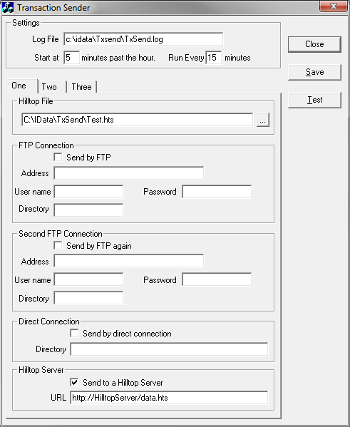
Tell TxSend to send the data to the server by ticking the check-box and then give the URL to get to the data file. You can use separate replication sessions to upload other data files on the server. TxSend uses a TxLoad request on the server and posts the XML replication documents. It optimises this transfer by combining multiple replication files into a single document.
The server authenticates TxSend by checking the IP address of the computer that TxSend is running on. This address must be defined in the Loaders entry in the HilltopSystem.dsn file. An example is:
[Server]
DataFile=C:\IData\Data\ServerDemo.hts
Loaders = 192.168.1.42, telemetry.hilltop.inet.nz

You can have a list of up to ten computers in the Loaders entry, and you can use an IP Address or a DNS name. Make sure the server can resolve the DNS name on its side of the firewall.
The IP address of the computer running TxSend may be subject to network address translation. You can find out the address presented to the computer using the WhoAmI request on the server. Start Interner Explorer, craft a URL with the request set to “WhoAmI” and the server will tell you the IP address it saw from your computer. For example:
http://host/data.hts?Service=Hilltop&Request=WhoAmI

You should also use Internet Explorer to test the data upload before running TxSend. This will let you fix authentication problems in an environment where you can see the error messages. Edit the Loaders entry in HilltopSystem.dsn and then reset the server to make it read the new settings. For example:
http://host/data.hts?Service=Hilltop&Request=Reset

Now test the upload with the TxLoad request. The server should reply with an error saying you didn’t offer an XML document. This is true. Try and fix any other error using the probably unhelpful message as a clue. An example test URL is:
http://host/data.hts?Service=Hilltop&Request=TxLoad

Roll your own Data Upload
You don’t have to use TxSend to upload data and are perfectly welcome to write your own client software. Post an XML document as the content and stand well clear. The XML dialect can be anything that Hilltop Manager will accept through a File – Open command, notably Hilltop XML, Niwa Xml or WML2.
You must be mindful of the amount of data you are uploading. By default, IIS limits the amount of data it will accept to 30 million bytes. You can use the IIS Manager to change this. Double click the Request Filtering icon for the web site the server is running on, and then choose Edit Feature Settings in the Action pane on the right hand side. Change the Maximum Allowed Content Length.
A much better way is to send compressed data to the server. The server will accept GZip or Zlib formats. You must tell the server the data is compressed and set the Content-Encoding header to “gzip” for GZip, or “deflate” for Zlib. Don’t send a Content-Encoding header if you are sending the XML uncompressed.
Your client should set two other request headers too. Set Content-Type to “text/xml” to say the data you are uploading in is XML, and set Accept to “text/xml” to show you are prepared to get the server’s reply as an XML document.

CSV Import
The server can import a CSV file and write the contents to a data file. Use the CSVImport request and give the name of the CSV form and a site name if the site name is not in the CSV form. The CSV data is sent to Hilltop Server as the payload in an HTTP POST command: An example URL is:
http://host/NewData.hts?Service=Hilltop&Request=CSVImport&Form=Water Meter&
SiteName=”12345M1”

The URL needs to identify a file to receive the data and you would configure this in the OtherServerFiles section of the HilltopSystem.dsn file. For example:
[Server]
DataFile=C:\IData\Data\ServerDemo.hts

[OtherServerDataFiles]
NewData = C:\IData\Data\DataFromCSVFiles.hts

The client must authenticate itself with HilltopServer so that only nice computers can write into the data files. The client software must provide a key in the HTTP header, and the servers checks the key against a list in the HilltopSystem.dsn file. You should sensibly have the server running HTTPS so that the header is encrypted.
The CSV Import keys are stored in the HilltopSystem.dsn file. You define a key in terms of the data file that you are allowing to receive the data and the actual key the client must send. Use a colon to separate the file name from the key, and you can have multiple key definitions separated by a comma. Blanks around the colon and comma are acceptable to improve readability. An example entry in the HilltopSystem.dsn is as follows:
[Server]
DataFile = C:\IData\Data\ServerDemo.hts
CSVImportKey = NewWaterUse:Open Sesame, Rainfall : Falls mainly on the plain

[OtherServerDataFiles]
NewWaterUse = C:\IData\Data\DataFromCSVFiles.hts
Rainfall = C:\IData\Data\DataFromCSVFiles.hts

Notice how the filename part of the import key refers to the entry in the OtherServerDataFiles section. This is the path that the client software must provide in the URL in order to write to the file.
The client must provide the CSVImportKey in the HTTP header. For example, the URL might be:
http://host/NewWaterUse.hts?Service=Hilltop&Request=CSVImport&Form=Water Meter&
SiteName=”12345M1”

And the header is:
Content-Type: text/plain
Accept: text/xml
CSVImportKey: Open Sesame

The search for the path and the actual key is case sensitive. The file name is part of the CSV key definition and this you can’t import into the default file. This is entirely by design. You can override this by giving a name to the data file that is the default and including it in the OtherServerDataFiles section.

OGC Services
The Hilltop Server accepts OGC compliant requests. The server provides basic documentation for the OGC commands, and this may be helpful to people who wish to fetch data from your server. Get them to point their web browser at the Hilltop Server with a nominal Hilltop file name. This will return an HTML page. For example:
http://host/help.hts

Web Feature Service
Information about the available data is returned using the Web Feature Service, WFS. The Hilltop Server implements three requests, being GetCapabilities, DescribeFeatureType, and GetFeature. The capabilities request lists the available feature types, and also describes the very limited filters the server will apply. The DescribeFeatureType gives details for the feature types. You can see the response from these requests in a web browser, as follows. Neither of the commands takes any other parameters.
http://host/data.hts?Service=WFS&Request=GetCapabilities
http://host/data.hts?Service=WFS&Request=DescribeFeatureType

The SiteList feature type is a list of sites, hence the name. Each entry in the list is the name of the site and its location. The MeasurementList feature type expands on the site list, but gives the measurements at the site, and the time range of the measurement.
The GetFeature request sends the data for the feature identified in the TypeName key. The request will also accept a bounding box.
http://host/data.hts?Service=WFS&Request=GetFeature&TypeName=SiteList
http://host/data.hts?Service=WFS&Request=GetFeature&TypeName=MeasurementList
http://host/data.hts?Service=WFS&Request=GetFeature&TypeName=SiteList&
BBox=-46.48797124,167.65999182,-44.73293297,168.83236546

The BBox key accepts two latitude and longitude pairs. The order of the pairs is not important, but the latitude precedes the longitude in each pair. The server needs to know which projection is being used in the Sites table, so make sure you have a Projection entry in the HilltopSystem.dsn file. Examples are:
[Hilltop]
Projection = NZMG ; The old system, NZ Map Grid
Projection = NZTM2000 ; The replacement system

You can also specify the bounding box in NZMG or NZTM2000. The proper OGC method is to have a Universal Resource Name at the end of the BBox value. The URN should be crafted in accordance with OGC 07-092, or else, and examples are:
urn:ogc:def:crs:EPSG::4326 WGS84 lat and long
urn:ogc:def:crs:EPSG::2193 NZTM 2000
urn:ogc:def:crs:EPSG::27200 NZMG
urn:ogc:def:crs:EPSG::4167 NZGD 2000

Thus a complete BBox entry using easting and northings in NZMG is:
BBox= 2100000,5400000,2180000,5600000,urn:ogc:def:crs:EPSG::27200

The server will convert the co-ordinates of the bounding box into the co-ordinates of the Sites table, and then do the search.

Lawa Table F
The server can prepare the data required for Table F in the Lawa data request. The type name was originally a nice simple name, but now is “MonitoringSiteReferenceData”, spelt as shown. Thus a URL to fetch the Table F is:
http://host/data.hts?Service=WFS&Request=GetFeature&TypeName=MonitoringSiteReferenceData

Sensor Observation Service
The Hilltop Server uses Sensor Observation Service, SOS, to transmit the data. The SOS implementation is restricted and the server only accepts the GetCapabilities and GetObservation requests. The SOS service doesn’t provide any meta-data, and only sends the data in WaterML 2.
The GetObservation request accepts a site name, measurement and time range. The names are of the keys are:
Site Name | FeatureOfInterest
Measurement | ObservedProperty
Time Range | TemporalFilter

Setting the Time Range
The TemporalFilter key is a Time Interval as defined in ISO8601 and full details are available at http://en.wikipedia.org/wiki/ISO_8601 . You can provide both a start time and a finish time, or just a start time and the server will read until the end of the data. The server will give the most recent value if you don’t provide a temporal filter at all.
Examples are:
TemporalFilter=om:phenomenonTime,2010-01-01T12:00:00/2011-07-01T14:00:00
TemporalFilter=om:phenomenonTime,2010-01-01T00:00

You can also give a duration, and this can be done in place of either the start or the finish time. A duration in ISO8601 has the letter ‘P’ then one or more pairs of numbers and letters. The letters refer to the units, and are obvious choices. The letter ‘M’ is used for both months and minutes so the duration must have the letter ‘T’ in it before the time of day units are used. Examples are:
P1Y | One year
P10Y | Ten years
P3M | Three months
P3D | Three days
P1Y3M | One year and three months
PT3H | Three hours
PT10M | Ten minutes
PT30S | Thirty seconds
P3MT3H30M | Three months, 3 hours and 30 minutes.

Examples are:
TemporalFilter=om:phenomenonTime,2010-01-01T12:00:00/P1Y
TemporalFilter=om:phenomenonTime,P1Y/2011-01-01T00:00
TemporalFilter=om:phenomenonTime,P7D

The first example gives a year of data from the given start time, and the second example gives the year before the given finish time. The third example has a duration by itself and this taken as interval back from the end of the available data. In the example, the command will return the seven days up to the most recent date and time.
An example of a GetObservation request is:
http://host/data.hts?Service=SOS&Request=GetObservation&
FeatureOfInterest=Alphabet River at Crossword&
ObservedProperty=Stage&
TemporalFilter=om:phenomenonTime, 2012-01-01T00:00/2012-11-01T00:00

Service Provider Information
Both WFS and SOS let you provide information about your organisation and this is done in a ServiceProvider node in the XML response to the a GetCapabilities request. The Hilltop Server uses a very simple system where it will insert the contents of a disk file into the GetCapabilities response at the point where the ServiceProvider node should appear. This lets you craft the XML yourself and the server will just send it. You need to make a text file called ServiceProvider.xml and put this file in the base directory for the server. This is the directory that has the HilltopSystem.dsn file in it. A sample Service Provider file is:
<ows:ServiceProvider>
<ows:ProviderName>Environment Chathams</ows:ProviderName>
<ows:ProviderSite xlink:href="http://www.chathams.govt.nz"/>
<ows:ServiceContact>
<ows:IndividualName>Hamish Townsend</ows:IndividualName>
<ows:PositionName>Chief Executive</ows:PositionName>
<ows:ContactInfo>
<ows:Phone>
<ows:Voice>+643 305-0811</ows:Voice>
</ows:Phone>
<ows:Address>
<ows:DeliveryPoint>12 Crayfish Drive</ows:DeliveryPoint>
<ows:City>Waitangi</ows:City>
<ows:PostalCode>8942</ows:PostalCode>
<ows:Country>New Zealand</ows:Country>
<ows:ElectronicMailAddress>Hamish@chathams.govt.nz</ows:ElectronicMailAddress>
</ows:Address>
</ows:ContactInfo>
</ows:ServiceContact>
</ows:ServiceProvider>

You must make sure the XML is well formed because Hilltop Server will not check it for you. Test your efforts in Internet Explorer because it will not display the XML unless it is correct. Use a URL like:
http://host/data.hts?Service=SOS&Request=GetCapabilities

Controlled Vocabulary
The OGC are big fans of a controlled vocabulary where you are only allowed to use measurements and units that are defined. There are efforts to build the necessary dictionaries and these are referred to through the use of Uniform Resource Identifiers, or URI’s for short. URI’s are just long complicated names, but OGC standards like the Water Quality data transfer standard, 14-003, ask that the URI’s resolve to an HTTP URL. This is double talk for “there is a web page at the address given in the URI”. Thus a reply from a server would give a web address for a site and measurement, and you could point your browser at this and see something.
Hilltop Server can generate a URI for observed properties and procedures. You provide the base URL, and then the server completes it. The base URI is set by the VocabularyURI setting in HilltopSystem.dsn . For example, there exists a perfect world where everyone agrees on site and measurement names and the URI points to “http://utopia.com/def/” . The HilltopSystem.dsn file looks like:
[Server]
VocabularyURI = http://utopia.com/def/

A request for stage will give the observed property and procedure as:
<om:observedProperty xlink:title="Stage"
href="http://utopia.com/def/property/Stage"/>
<om:procedure xlink:title="Water Level"
href="http://utopia.com/def/procedure/Water Level"/>

The server appends a sub-directory name of property or procedure, and then puts on the name of the measurement and data source.

Roll your own Vocabulary
There isn’t a New Zealand wide or world-wide vocabulary server, but Hilltop Server can provide an HTTP end-point to your own vocabulary. This means that the URI’s that go out with the observed property and procedure will give a web page if someone connects to them using a browser, and Hilltop Server can serve up that web page. The data to power the web page is read from the Hilltop Tables on the server.
The screen shot shows a URL inquiring about Water Level. The layout of the web page is set by a stylesheet that you can modify.
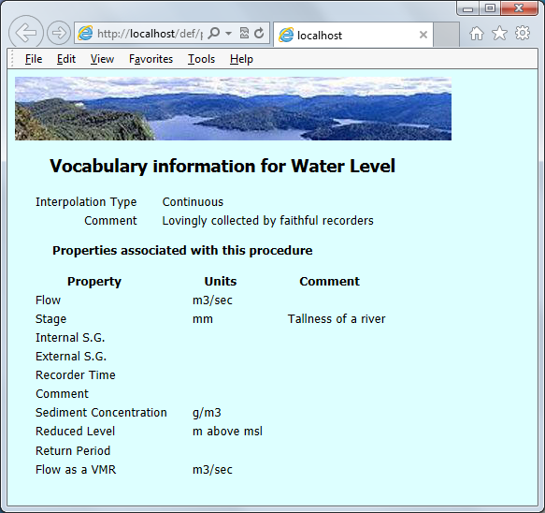
Naturally, there is a complicated set-up step to make this happen. The process involves defining a new virtual directory on your web server and then telling IIS that Hilltop Server will process all requests that refer to the virtual directory.
Start the IIS Manager and click on the web site that is running Hilltop Server
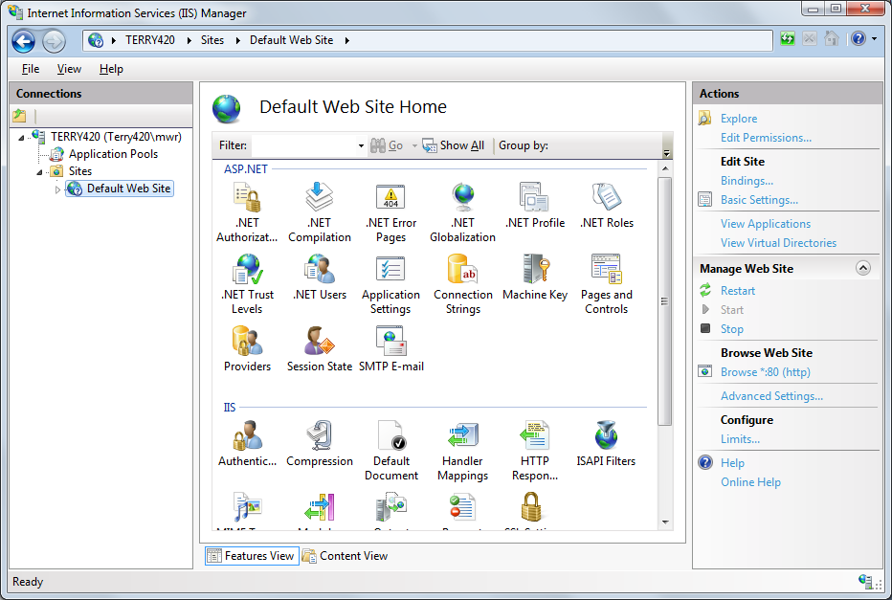
Right mouse click on the name of web site, and choose the Add Virtual Directory menu item. A dialog box will appear and you need to name a directory, called the Alias, and its location on your computer. You must name the Alias “def” because Hilltop Server won’t work unless you do!!
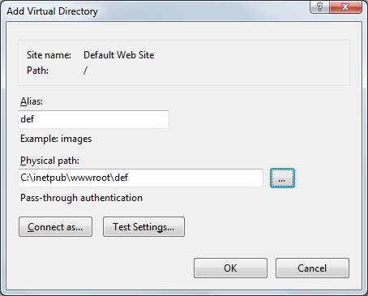
Next click on the def directory and double click on the Handler Mappings icon.
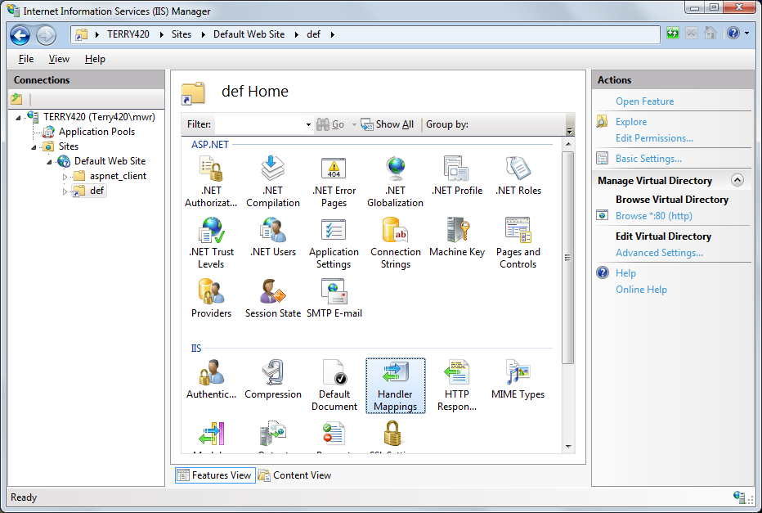
The Handler Mappings screen will start and there is an “Add Module Mapping” link in the Actions pane. Click this and a dialog will start.
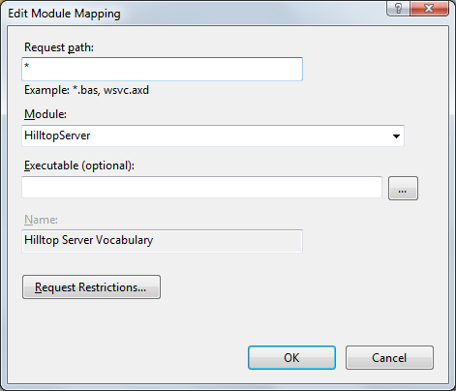
The request path is “*” and this step tells IIS that Hilltop Server is to answer all requests to the /def/ directory and any sub-directories. Hilltop Server will inspect the URL it gets from the browser and build the reply. It first makes an XML document and then passes this through an XSLT stylesheet. This process lets you design the layout of the web page that shows the vocabulary information.
The two examples show the XML that is built when the client asks for a procedure and a property.
<?xml version="1.0"?>
<HilltopServerVocabulary>
<Hello>Mark</Hello>
<DataSource>Water Level</DataSource>
<InterpolationMethod>Continuous</InterpolationMethod>
<Comment>Lovingly collected by our faithful recorders</Comment>
<Measurements>
<Measurement>Flow</Measurement>
<Units>m3/sec</Units>
<Comment></Comment>
</Measurements>
<Measurements>
<Measurement>Stage</Measurement>
<Units>mm</Units>
<Comment>Tallness of a river</Comment>
</Measurements>
<Measurements>
</HilltopServerVocabulary>

<?xml version="1.0"?>
<HilltopServerVocabulary>
<Hello>Mark</Hello>
<Measurement>Flow</Measurement>
<DataSource>Water Level</DataSource>
<Units>m3/sec</Units>
<Comment>Flow is built from a rating curve</Comment>
</HilltopServerVocabulary>

The XML for a procedure has the interpolation method and any comment that you have typed into the Data Sources editor in Hilltop Manager. The XML also has a list of the measurements associated with the data source. The XML for the measurement has the data source name, the units, and any comment that you have stored with the Measurement.
The next two examples are simple stylesheets that make the HTML for the browser. Copy these examples to the /def/ directory and name them “procedure.xsl” and “property.xsl” respectively.
<?xml version ="1.0"?>
<xsl:stylesheet xmlns:xsl="http://www.w3.org/1999/XSL/Transform" version="1.0">
<xsl:output method="html"/>
<xsl:template match="HilltopServerVocabulary">
<html>
<head>
<style type="text/css">
th { font-family: Tahoma; font-size: 10pt;}
td { font-family: Tahoma; font-size: 10pt; padding-left: 20; padding-right: 5 }
.DCell { text-align: Right; }
h2 { font-family: Tahoma; font-size: 14pt; text-indent: 2em; }
h3 { font-family: Tahoma; font-size: 10pt; text-indent: 3em; }
</style>
</head>

<body bgcolor="#ddffff">
<img src="/images/lake.jpg"/>
<h2>Vocabulary information for <xsl:value-of select="DataSource"/></h2>
<table>
<tr><td class="DCell">Interpolation Type</td><td><xsl:value-of select="InterpolationMethod"/></td></tr>
<tr><td class="DCell">Comment</td><td><xsl:value-of select="Comment"/></td></tr>
</table>

<h3>Properties associated with this procedure</h3>
<table>
<tr><th>Property</th><th>Units</th><th>Comment</th></tr>
<xsl:for-each select="Measurements">
<tr>
<td><xsl:value-of select="Measurement"/></td>
<td><xsl:value-of select="Units"/></td>
<td><xsl:value-of select="Comment"/></td>
</tr>
</xsl:for-each>
</table>
</body>
</html>
</xsl:template>
</xsl:stylesheet>

<?xml version ="1.0"?>
<xsl:stylesheet xmlns:xsl="http://www.w3.org/1999/XSL/Transform" version="1.0">
<xsl:output method="html"/>
<xsl:template match="HilltopServerVocabulary">
<html>
<head>
<style type="text/css">
td { font-family: Tahoma; font-size: 10pt; padding-left: 20; padding-right: 5 }
.DCell { text-align: Right; }
h2 { font-family: Tahoma; font-size: 14pt; text-indent: 2em; }
</style>
</head>

<body bgcolor="#ddeeff">
<img src="/images/lake.jpg"/>
<h2>Vocabulary information for <xsl:value-of select="Measurement"/></h2>
<table>
<tr><td class="DCell">Units</td><td><xsl:value-of select="Units"/></td></tr>
<tr><td class="DCell">Procedure</td><td><xsl:value-of select="DataSource"/></td></tr>
<tr><td class="DCell">Comment</td><td><xsl:value-of select="Comment"/></td></tr>
</table>
</body>
</html>
</xsl:template>
</xsl:stylesheet>

The stylesheets have an <img> tag in them to load a picture. The picture must not be located in the /def/ directory. Hilltop Server is intercepting all requests to /def/ but it is not clever enough to dispatch the image files. Put them elsewhere and let IIS send the image directly.

Clients
You can write your own client to talk to the server or use Hilltop clients. The Hilltop clients always think they are reading data from a file, but of course it’s now a File DSN. The File DSN has a style of HTServer and contains the URL to get to the server. You need to provide the path, with an optional port number, and a filename with the filename extension that is mapped to the server. An example is:
[Hilltop]
Style=HTServer
URL=http://example.co.nz/Data.hts

Don’t put any key-value pairs on the URL, the Hilltop clients will do this for you.

Hilltop Manager
Hilltop Manager provides a full function view into the Hilltop Server. It knows it is connected to the server and asks for an image when you ask for a graph. It will ask the server for data if you run the Data – List or Data – View or Data-Copy commands. The server is read-only so Data – Delete won’t work, and just as well.
Hilltop clients will pass the site and measurement names through the Hilltop Transfers table. This means you can arrange to see the data using names of your choice. Create an Agency that matches that sent by the server, and then define substitute site names and measurements as usual. You can see the agency for the server in Hilltop Manager. Open the File DSN in Hilltop Manager and the agency will be shown in the results pane on the right hand side of the window.

Hilltop on the Web
At first sight, the Gifgen component in Hilltop on the Web is no longer required since the Hilltop Server can do the same thing. The reality is quite different if you are presently using Gifgen. This is because, at present, Gifgen needs to be able to see the data and meta-data in SQL Server, and so will be either be inside the firewall with reduced security, or be outside the firewall and you will have to throw data across the firewall using TxSend.
Gifgen can talk to the Hilltop Server and so you can create a completely secure system without having to move data across the firewall. Move the script driving Gifgen to an Internet facing server outside the firewall, if it’s not there already, and change the script so that it sets the DataFile property to name a File DSN. The File DSN contains connection information to the Hilltop Server. Gifgen will accept the properties and methods as per usual, but when you invoke the GetGraph method, Gifgen will prepare the XML document, send it to the server and deliver the image back to your script as per normal.
The File DSN looks like:
[Hilltop]
Style=HTServer
url = http://PhoneAFriend:8025/ThankYou.hts

The URL contains connection information to get to the computer running the Hilltop Server. The firewall will have a pin hole in it to allow the traffic through on the given, non-standard port. In this case, the port is 8025.

Scripting Languages
Script using Hydrolib will work with the Hilltop Server when reading data. Specify a File DSN instead of a Hilltop file in the Open methods for the various objects. You will get best performance if you are using a DataFile object because this will reduce the number of trips to the server. This works well for script written in R, Python and Visual Basic.

htsUpdate
You can use a Hilltop Server as the source file and so copy new data to a local data file. You can still use the S or D options to determine if the source or destination file is controlling the copy. It is polite to use Hilltop Manager to copy a short, recent amount of data when first starting an update. The owner may or may not like you capturing all the data from a site.

Merge File DSN’s
The server will accept a Merge File DSN as a data file and this lets you offer a combination of data files via a single filename in the URL. The server reads its data using the same software as any other client, and so can read data from another server. This intriguing design means that your server can offer your own data plus someone else’s.
Note that the Hilltop Server is not aware it is connected to another server and so will always ask for the data in order to prepare a graph. This is fine if your server is connected to a Kisters or Cuahsi server, but is not efficient if connected to another Hilltop Server. Future versions of the Hilltop Server will detect this “relaying”, and react accordingly.

Web Sites
Hilltop Server is designed to work with a web site and will help make your web site configurable and dynamic. You will need to write software to drive the site and your web site designer will choose to have this software run on a Web Server or on the customer's computer. This is called "Server Side" or "Client Side" programming.
Server Side software is mostly likely written in either C# or PHP. Client side software is written in JavaScript. All languages work as well or as badly as each other, and designers love to debate the relative merits.
The screen shot shows a web site written in Javascript and it makes calls to Hilltop Server to build the graphs. The web page asks the server for a list of sites and the user chooses one from the drop down list. That done, the Javascript asks for a list of measurements at the site, and then they pick a measurement and get a graph. The navigator pane lets them zoom in on the graph. The page is very fast because Hilltop Server is providing the graphs.
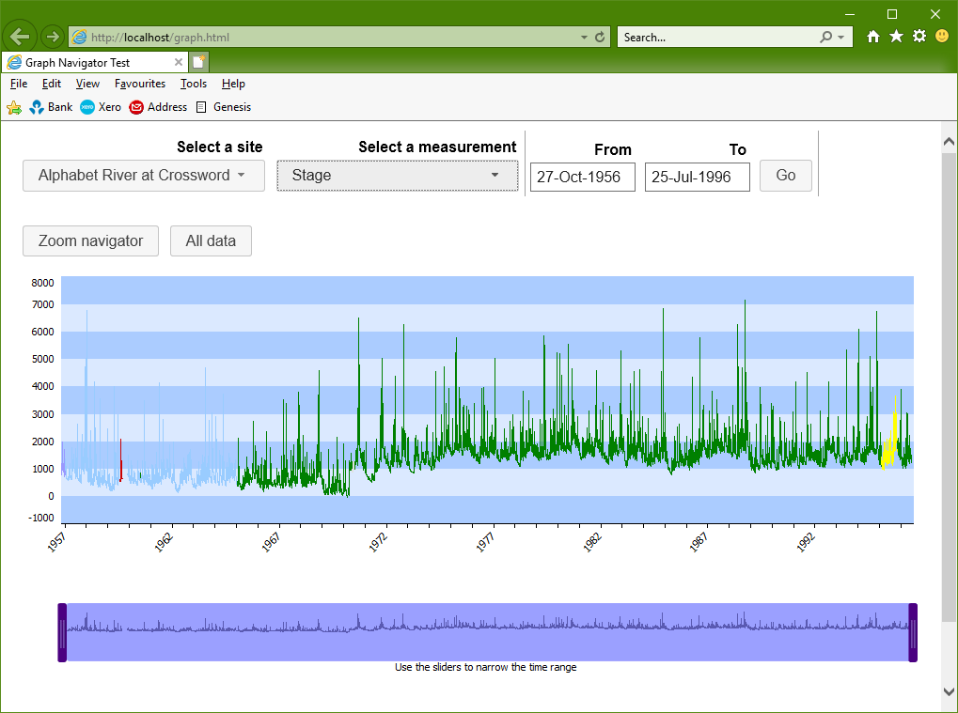

Image Specification
The XML document posted with the Gifgen request must be laid out by the rules. Rather than list all the elements using an XML Schema, this section takes you through the various parts of the document. Each part of the document is like a chapter in a book, and has its own nesting level. Most of the elements have a default value and this is useful when you are first experimenting with the server. Selecting the default is handy because it means you don't have to provide an element.
A simple XML document to get a graph is:
<?xml version=”1.0”?>
<HilltopImage>
<Size X=”800” Y=”350” />
<Graph>
<Axes>
<Axis Direction=”Horizontal”>
<From>1/1/2012</From>
<To>1/11/2012</To>
</Axis>
</Axes>
<Traces>
<Trace Site=”Alphabet River at Crossword” Measurement=”Flow” />
</Traces>
</Graph>
</HilltopImage>

The From and To elements give the time range, and the Trace element identifies the site. The vertical axis is auto-scaled.
At the most outer level, the XML document has a HilltopImage document node, and optional parameters for the size of the image, the image format and background colour. An example is:
<HilltopImage>
<Size X=”800” Y=”350” />
<Format>GIF</Format>
<BackgroundColour>White</BackgroundColour>
</HilltopImage>

The size of the image is given in pixels and defaults to 800 by 400. You will almost certainly want to set the size yourself. The Format element can also request a PNG format, but this is slower to produce. The default background colour is white. You can specify colours using the Hilltop names, or use the Internet RGB convention of “#rrggbb”.

Graph
The next layer is a Graph node. A graph is a set of axes with data drawn as traces. The document structure allows for more than one graph on an image, but the Hilltop Server will not do this at present. The Graph nodes follows the outer elements like so:
<HilltopImage>
<Size X=”800” Y=”350” />
<Format>GIF</Format>
<BackgroundColour>White</BackgroundColour>
<Graph>
←- Stuff to talk about the graph -→
</Graph>
</HilltopImage>

Elements in the Graph node set the axis colour, the inner background colour, the alternate inner background colour, and the axis label font. Examples are:
<Graph>
<AxisColour>Black</AxisColour>
<InnerBackgroundColour>Pale Sky Blue></InnerBackgroundColour>
<AltInnerBackgroundColour>#eeeeff</AltInnerBackgroundColour>
<GraticuleColour>Blue</GraticuleColour>
</Graph>

There are defaults for all these elements. They are:
Axis colour | Black
Inner background colour | Pale Sky Blue
Alternate inner background colour | Auto
Graticule colour | Auto

The axis labels are written in the default font which is 8pt Tahoma. You can override this with a DefaultFont node as follows:
<DefaultFont>
<TypeFace>Arial</TypeFace>
<Height>10</Height>
<Bold/>
<Italic/>
<Underline/>
<Colour>Green</Colour>
<AlphaBlend>50</AlphaBlend>
</DefaultFont>

Insert a DefaultFont node inside the Graph node, and only provide the elements that you require. For example, don’t give a Bold, Italic or Underline element unless you want them.
A Graph node that relies on the defaults but still has some customisation might look like:
<Graph>
<InnerBackgroundColour>Pale Pink</InnerBackgroundColour>
<GraticuleColour>Light Blue</GraticuleColour>
<DefaultFont>
<TypeFace>Arial</TypeFace>
<Height>10</Height>
<Colour>Dark Gray</Colour>
</DefaultFont>
</Graph>

A More Modern Look
Contemporary graphs are drawn with an emphasis on “data ink”, and so there are less lines and labels on the graph. Set the ModernAxisBox in the Graph node, for example:
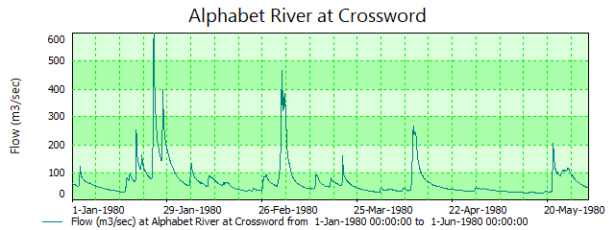
<Graph>
<ModernAxisBox />
</Graph>

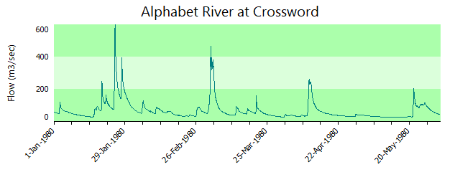

Time Axis Label Orientation
The time axis labels are drawn horizontally under the axis but you can have them drawn at 45 degrees. Put an AngleAxisLabels element in the Graph node, for example:
<Graph>
<AngleAxisLabels />
</Graph>

Sparklines
A sparkline is a graph that doesn't have any axes or labels. All the background colours are set to white in a sparkline, and you must reset the background colours after the Sparkline element if you want a different colour. For example:
<Graph>
<Sparkline />
<InnerBackgroundColour>Pale Green</InnerBackgroundColour>
<AltInnerBackgroundColour>None</AltInnerBackgroundColour>
</Graph>
The trace label is never drawn on a sparkline, but you can have top and bottom labels. You may wish to set the background colour if you are using titles and don't want the text on a white background.

Axes
The graph has a vertical axis range on the left hand side, and up to five vertical axes on the right hand side. There is also a horizontal range which is usually a time range. You will need to provide the range for the axes, or let the server determine them for you. The Axes node sits inside the Graph node:
<Graph>
←- Stuff to talk about the graph -→
<Axes>
←- Stuff to talk about the axes -→
</Axes>
</Graph>

Information about each axis is given in an Axis node. The horizontal axis is defined like:
<Axes>
<Axis Direction=”Horizontal”>
<From>1/1/2012</From>
<To>1/11/2012</To>
<TickSpacing>1 month</TickSpacing>
<LabelSpacing>3</LabelSpacing>
</Axis>
</Axes>

The TickSpacing and LabelSpacing elements are optional because the Hilltop Server will compute these for itself based on the image size and the time range. However, the settings are available if you think the software has put in too many ticks, or has crashed the labels together. Note the LabelSpacing is a multiple of the ticks, so in the example given, there will be a tick and grid line every month, and a label every three months.
The vertical axes are defined in an Axis node too. Each vertical axis has a number, zero for the left hand axis and one to five for the right hand axes. A simple left hand vertical axis is:
<Axis Direction=”Vertical” AxisNumber=”0”>
<Min>0</Max>
<Max>5000</Max>
</Axis>

The vertical axis node must be inside the Axes node, so an example definition is:
<Axes>
<Axis Direction=”Horizontal”>
<From>1/1/2012</From>
<To>1/11/2012</To>
</Axis>
<Axis Direction=”Vertical” AxisNumber=”0”>
<Min>0</Max>
<Max>5000</Max>
</Axis>
</Axes>

The default is to auto-scale the vertical axes, or use a preset range if this has been defined in the thresholds table. Note that the preset range is set on the server computer, not yours.
The Min and Max elements can have other elements to tell the server how to choose the value. Each attribute has the same meaning for Min or Max elements. Examples of the optional attributes are:
<Min AutoScale=”Yes”/>
<Min AutoScale=”Yes” Align=”100”/>
<Min Preset=”Yes”/>

Traces
The data is drawn as one or more traces. Each trace belongs to a vertical axis, and you specify this in the Trace element. You use traces to provide an overplot. The Traces node sits inside the Graph node, and follows the Axes node. This order isn’t necessary but it helps human readability.
<Graph>
←- Stuff to talk about the graph -→
<Axes>
←- Stuff to talk about the axes -→
</Axes>
<Traces>
←- Stuff to talk about the traces -→
</Traces>
</Graph>

There is a Trace node for each times series to be drawn on the graph. The Trace node requires a site name and measurement, and you can optionally provide a colour and line style. An example is:
<Trace Site=”Alphabet R. at Crossword” Measurement=”Flow” AxisNumber=”0”>
<Pen>
<Colour>Blue</Colour>
<Style>2</Style>
<Thickness>5</Thickness>
<MarkerSize>4</MarkerSize>
</Pen>
</Trace>

The Pen node sets the colour of the trace and line style. All elements are optional, but you will usually provide a least a colour. The Style is a magic number as follows
0 Solid
1 Dash
2 Dot
3 Dash Dot
4 Dash Dot Dot

You must provide an interval when drawing Incremental data such as Rainfall. Insert an Interval element, for example:
<Trace Site=”Alphabet R. at Crossword” Measurement=”Rainfall” AxisNumber=”0”>
<Interval>1 day</Interval>
<Pen>
<Colour>Blue</Colour>
</Pen>
</Trace>

The software can draw various statistics such as fixed or moving means. Place one of the following elements in the Trace node:
<ActualData/>
<FixedAverage/>
<MovingAverage/>
<MovingVolume/>
<DailyMean/ >

The default is to draw the actual data. The fixed and moving averages require an Interval element, as does the moving volume. The moving calculations always set the trace back by half the interval.
Overplots are done by adding more Trace nodes. There isn’t a limit in the software, but the graph can look too busy. A simple example of two flows on the same left hand axis is as follows. The second trace is a six hour moving mean.
<Traces>
<Trace Site=”Alphabet R. at Crossword” Measurement=”Flow” AxisNumber=”0”>
<Pen><Colour>Blue</Colour></Pen>
</Trace>
<Trace Site=”Anakina R. at Duntroon” Measurement=”Flow” AxisNumber=”0”>
<Pen><Colour>Dark Green</Colour></Pen>
<MovingMean/>
<Interval>6 hour</Interval>
</Trace>
</Traces>

Bar Graphs
Water Quality data can look better drawn as a bar graph, especially if you are not looking for trends. The method is to give a Bar node as well as the Pen node. For example:
<Trace Site=”Alphabet R. at Crossword” Measurement=”NH4” AxisNumber=”0”>
<Pen>
<Colour>Blue</Colour>
</Pen>
<Bar>
<Width>7</Width>
<BorderColour>Blue</BorderColour>
</Bar>
</Trace>

The bar is drawn using the Pen colour, and you can have an optional border around the bar. The default colour for the border is black, but you can set it to the colour of the bar to hide the border. The width of the bar is defined in one of two ways. A number by itself sets the width of the bar in pixels. The default is 4 pixels. You can also give an interval, and then the bar will take up the given width. This is handy for drawing averages and has the effect of separating the bars. For example, you might be drawing monthly average flow, but set the bar width to 20 days. Each bar is now only 20 days wide, and will be centred in the month. The bars will have space between them.
The software can draw a small box above the bar and write the value of the measurement. You request this feature by specifying a DataLabel node, and giving the software the background colour for box, and a colour for the border around the box. For example:
<Trace Site=”Alphabet R. at Crossword” Measurement=”NH4” AxisNumber=”0”>
<Pen>
<Colour>Blue</Colour>
</Pen>
<Bar>
<Width>7</Width>
<BorderColour>Blue</BorderColour>
<DataLabel>
<BackgroundColour>Pale Yellow</BackgroundColour>
<BorderColour>Grey</BorderColour>
</DataLabel>
</Bar>
</Trace>

The text in the label is controllable and is done using a Font node. This is described in the next section, Labels. To specify 8pt Tahoma in blue you would write:
<Trace Site=”Alphabet R. at Crossword” Measurement=”NH4” AxisNumber=”0”>
<Pen>
<Colour>Blue</Colour>
</Pen>
<Bar>
<Width>7</Width>
<BorderColour>Blue</BorderColour>
<DataLabel>
<BackgroundColour>Pale Yellow</BackgroundColour>
<BorderColour>Grey</BorderColour>
<Font>
<TypeFace>Tahoma</TypeFace>
<Height>8</Height>
<Colour>Blue</Colour>
</Font>
</DataLabel>
</Bar>
</Trace>

Labels
You can have various labels on the graph and these are specified inside a Labels node. The Labels node sits inside the Graph node, but the order in relation to the Axes and Traces nodes is not important.
<Graph>
←- Stuff to talk about the graph -→
<Axes>
←- Stuff to talk about the axes -→
</Axes>
<Traces>
←- Stuff to talk about the traces -→
</Traces>
<Labels>
←- Stuff to talk about the labels -→
</Labels>
</Graph>

Each label is defined as another node. Valid label names are:
Top | A label above the graph and outside the axis box.
Bottom | A label at the very bottom of the graph, below the trace labels
TopLeft | A label in the top left corner of the axis box.
TopRight | A label to the top right corner of the axis box.
Vertical | A label on the left vertical axis
RightVertical | A label on the first right hand vertical axis
TraceLabel | The format for the trace label at the bottom of the graph.
WaterMark | Text written inside the graph as a water mark.

A label has various attributes and these are controlled by elements inside each label node. The Text element defines the label text, and the Font node sets the type face, height etc. An example to set the label at the top of the graph is:
<Labels>
<Top>
<Text>The Greatest Graph Ever</Text>
<Font>
<TypeFace>Arial</TypeFace>
<Height>16</Height>
<Bold />
<Colour>Blue</Colour>
</Font>
</Top>
</Labels>

Text
The text can have parameter substitution rules that let you define the text for a label without having to change it for each graph. Parameters are reserved words enclosed in percent signs. The server scans each label as it prints it and replaces the reserved word with its actual meaning. For example, you might set the top left label to "This is a graph of %site%". The "%site%" text is replaced by the actual site name when the graph is drawn.
Valid parameters are as follows. Capital letters or lower case doesn't matter.
%filename% | The name of the data file
%site% | The site name
%measurement% | The measurement including the units
%units% | The units of the measurement
%total% | The total rainfall when drawing rainfall. Text is "Total= xxx"
%gtime% | The date and time the graph was drawn
%stime% | The start date and time of the time axis
%ftime% | The finish date and time of the time axis
%sdate% | The start date of the time axis
%fdate% | The finish date of the time axis
%esdate% | The start date of the envelope calculation
%efdate% | The finish date of the envelope calculation
%ktime% | The date and time of the most recent reading
%kvalue% | The value of the most recent reading
%t24% | The total rainfall in the last 24 hours, when drawing rainfall

Font
The Font node is a little ponderous because a font can have several settings. The example below shows all possible options.
<Font>
<TypeFace>Arial</TypeFace>
<Height>16</Height>
<Bold />
<Italic />
<Underline />
<Colour>Blue</Colour>
<AlphaBlend>35</AlphaBlend>
</Font>

Select a type face from the ones available on the server. The Height is this height of the text in points. Choose the Bold, Italic and Underline elements if you want them, and don’t provide the element if you don’t want it. The Colour is the Hilltop name of the colour, or use the Internet RGB convention of “#rrggbb”.

Water Mark
The water mark is a label drawn inside the graph and it appears to be above the inner background colour and below the grid lines and data traces. It lets you insert a quiet message proclaiming the quality of the data. The Font node for the water mark can accept an “alpha blend” number and this controls how the water mark mixes with the background colour. The alpha blend defaults to 30, and can be in the range 1 to 255. Low numbers make the water mark more washed out, and the high numbers make the water mark more prominent. Use the AlphaBlend element as part of the Font specification.
You can choose a colour for the water mark text, but black is a good start because it makes the letters appear in a darker version of the background colours.
The water mark is centred in the graph by default. You can override this by putting X and Y attributes in the WaterMark node. The x and y offsets are in pixels from the bottom left corner of the axes. For example, to set the water mark 100 pixels across and 40 pixels up, and have the characters stronger:
<WaterMark X=”100” Y=”40”>
<Text>Certified Data</Text>
<Font>
<TypeFace>Arial</TypeFace>
<Height>20</Height>
<Bold />
<AlphaBlend>40</AlphaBlend>
</Font>
</WaterMark>

Thresholds
Gifgen can draw lines and coloured regions in the graph. The thresholds are defined inside a Thresholds node. The Thresholds node sits inside the Graph node, and follows the Axes node. This order isn’t necessary but it helps human readability.
<Graph>
←- Stuff to talk about the graph -→
<Axes>
←- Stuff to talk about the axes -→
</Axes>
<Traces>
←- Stuff to talk about the traces -→
</Traces>
<Thresholds>
←- Stuff to talk about the thresholds -→
</Thresholds>
</Graph>

The ShowThresholds element tells Gifgen to display the thresholds lines defined in the Hilltop Thresholds table. The ShowValidDataLimits element tells Gifgen to show the upper and lower limits for valid data, as defined in the Thresholds table. Both options default to being off, so you will need to provide the appropriate element to turn the setting on. Examples are:
<Thresholds>
<ShowThresholds />
<ShowValidDataLimits />
</Thresholds>

Your own threshold lines are defined using the Line element. You need to provide a Value attribute for the position of the line, a Colour attribute, and a Title attribute. Note the Value attribute uses the range of the left hand vertical axis to determine where to place the line. An example is:
<Thresholds>
<Line Value=”125” Colour=”Dark Blue” Title = “Shift the cows now.” />
</Thresholds>

Threshold regions are defined with the Region element. You give a Min and Max attribute to give the range of the region and a Colour attribute for region fill. An example is:
<Thresholds>
<Region Min=”0” Max=”50” Colour=”Light Green”/>
</Thresholds>

